Pushy Jerks: A Bar Simulation
Wesley K. Sun | EECS 472 | S 2013

Overview
Inspired by the El Farol bar problem, this project seeks to model and analyze another social behavior seen in bars, the behavior of crowds on a busy night. This project focuses on how some bar patrons are pushier than others and looks at the effect that that behavior has on everyone else. It will also explore how each patron’s pushiness can vary over time as a result of various causes.

What can be learned
The main goal of this model is to provide a visual and measurable of showing the effect that selfish behaviors have on other members of the crowd. Specifically, given a distribution of people with varying amounts of pushiness, how does that affect the average wait time of everyone? How does that affect the average wait time of subsets of people with a specific level of pushiness? What would happen if agents grew pushier over time as a result of waiting too long or drinking? It will show who these selfish behaviors are detrimental to and the magnitude of the effect. This model will show these consequences in an easy to understand way.

Motivation/Rationale
The motivation of this project stems from a personal experience as well as the experiences of many others where people who are pushier than most would force their way to the bar counter, much to the annoyance of those around me. I was curious to see this situation modeled and analyzed to see how it affects the crowd as a whole as well as subsets of the crowd.
Using multi-agent modeling to create this simulation is the most sensible choice for this project as it provides a great visualization of what is happening. It’s also a great medium for translating human behavior to code that behaves analogously to those behaviors.

Rules
The model is built off of Dirk Helbing and Péter Molnár’s social forces model[1]. It’s their solution to simulating pedestrian movement in crowded situations. The basic premise of the model is that there are “social forces” that are internal motivations in each agent that drive where they move towards next. These forces can be caused by the position of the goal, surrounding obstacles, and other agents. The pushy jerks model uses the social forces model to drive each agent’s locomotion.
The social forces model was modified to fit the needs of the simulation and is broken into three calculations. To determine where I, the agent, will be in the next time-step, the first calculation is for the driving force of me towards the goal. The equation for the driving force is:
$$F_{α}^{0}=\frac{p_{α}}{τ}\left(v{}_{0}e_{α}−v_{α}\right)$$
This calculates the driving force for me, $α$, where $τ$ is the relaxation time, which modulates how much I accelerate towards my desired speed, $v{}_{0}$. Other important variables are $e_{α}$, the unit vector pointing towards the nearest goal, $v_{α}$, my current velocity, and most important of all, $p_{α}$, how pushy I am.
Next are the forces caused by nearby agents, $f_{αβ}$. This is referred to as the territorial effect by Helbing and Molnár and is given by the following equations:
$$f_{αβ}=−\left(V | | 0e^{\frac{−b}{σ}}\right)n_{βα}$$
$$b=\sqrt{}$$
For each agent $β$ who is not me, the territorial effect is calculated from the previous equations and summed up to provide the total territorial effect from all of my neighbors. In this equation, $V^{0}$ and $σ$ are both arbitrary constants with which the model can be tuned. The remaining variables are $n_{βα}$, the unit vector pointing from me to $β$, $r_{αβ}$, the vector that is the subtraction of the position of $β$ from my position, $v_{β}$, the velocity of $β$, and $e_{β}$, the desired direction of $β$.
In addition, the territorial forces are also modulated by my field of view. If agent $β$ is within my field of view, the territorial force due to that agent is in full effect, otherwise it is multiplied by a constant, c, where 0 < c < 1. As a result, the actual territorial effect caused by an agent is:
$$F_{αβ}=w\left(e_{α},f_{αβ}\right)f_{αβ}$$
$$w\left(e,f\right)=\left\{\begin{aligned}1ife∙f≥\left|f\right|cosφ \\ cotherwise\end{aligned}\right.$$
Where $φ$ is half of my field of view.
The final source of the forces is the obstacles. The force equation for the obstacles are similar to those of the territorial effect and are given by:
$$F_{αB}=−\left(U | | 0e^{\frac{\left|r_{αB}\right|}{R}}\right)n_{Bα}$$
For each obstacle B, the obstacle forces are summed up to form the total obstacle force on me where, once again, $U^{0}$ and R are arbitrary constants that are used to tune the model. The variables are $r_{αB}∨$, the distance between B and I, and $n_{Bα}$, the unit vector pointing from me to $B$.
Finally, my desired acceleration, $\frac{dw_{α}}{dt}$, is the sum of all these forces:
$$\frac{{dw}_{α}}{dt}=F_{α}^{0}+\sum_{β}{F_{αβ}}+\sum_{B}{F_{αB}}$$
This value is added to my current velocity.
$$v_{α}=v_{α}+\frac{dw_{α}}{dt}$$
Then it needs to be scaled to ensure that my desired speed is not being exceeded.
$$v_{α}=v_{α}g\left(v_{α}\right)$$
$$g\left(v\right)=\left\{\begin{aligned}1if\left|v\right|≤v^{0} \\ \frac{v^{0}}{\left|v\right|}otherwise\end{aligned}\right.$$
To make it possible to run these calculations, the agents in the model must have the following attributes:
- pushiness, how hard I currently will push towards the goal
- vx and vy, the x and y values of my velocity
- desired-direction, the direction that is towards the goal
- driving-forcex and driving-forcey, my driving force
- obstacle-forcex and obstacle-forcey, my obstacle force
- territorial-forcex and territorial-forcey, my territorial force
In addition, the agents have additional attributes that the model requires:
- thirsty?, whether or not I am thirsty
- drinks-had, how many drinks have I had so far
- base-pushiness, how pushy I am originally
To set up the simulation:
- create patrons agents and position them in the center of the view
- set each agent’s thirsty? to false
- set each agent’s vx and vy to a unit vector that is pointing towards the goal, give or take up to 90 degrees
- set each agent’s drinks-had to 0
- set each agent’s base-pushiness to a random number that is uniformly distributed between lower-pushiness and upper-pushiness
- set each agent’s pushiness to its base pushiness
- set up the view so that the edge patches are all obstacles
- set up a bar counter where the counter is made of obstacle patches and the bartenders are goal patches
To go, on each tick:
Agents with thirsty? = true:
- calculate my desired-direction according to the social forces model
- calculate my driving-forcex and driving-forcey according to the social forces model
- calculate my obstacle-forcex and obstacle-forcey according to the social forces model
- if I am not the only turtle, calculate my territorial-forcex and territorial-forcey according to the social forces model
- move according to my forces and the social forces model
- if get-impatient (agents grow impatient and thus more pushy the longer they wait) then I will increment my pushiness by impatience-rate, making sure that my pushiness does not exceed upper-pushiness
If there are any agents with thirsty? = false
- generate a random float between 0 and 1
- if that float is less than 1 / mean-time-between-intervals, tell one of the agents who are not thirsty to be thirst (set thirsty? to true)
To serve one of the agents:
- generate a random float between 0 and 1
- if that float is less than 1 / mean-time-between-service, tell one of the goal patches (bartenders) to serve an agent
To serve an agent:
- if there are any agents within 2.5 of me (near the counter) I continue with the next steps
- if my service-plan is “random” then the agent to be served is one of the agents within 2.5 of me
- if my service-plan is “waited-longest” then the agent to be served is the one within 2.5 of me who has waited the longest
- I ask the agent to be served:
  - I set my position to the center of the view
  - I set thirsty? to false
  - I set my initial velocity the same way it is set in the set up
  - I increment drinks-had by 1
  - I reset my pushiness back to base-pushiness
  - If get-belligerent = true then I set my pushiness to be base-pushiness + drinks-had * belligerence-rate

Validation

The social forces model
Using the social forces model for the Pushy Jerks model is appropriate as it provides a reasonably accurate simulation of crowding. In their own studies, Helbing and Molnár found that their model realistically simulated crowds where agents moved in opposite directions. In addition one of the most easily noticeable behaviors exhibited by the model is the circular shape surrounding a goal that the crowd will take on, which is behavior that is also seen in the real world.

Having agents grow pushier
In a poll, participants were asked how their behavior changed the longer they had to wait to get a drink, with the responses ranging from 1, less pushy, to 5, more pushy. Fifteen responses were recorded, two were from people who didn’t drink so their entries were removed:
Mean = 4.38; standard deviation = 0.65; 95% confidence interval = 4.02 – 4.74
This shows a rather strong indication that increased wait time will result in increased pushiness from the agents.
In addition, participants were asked how their behavior changes as they consume more drinks, with the response range being the same as that of the previous question:
Mean = 3.46; standard deviation = 0.97; 95% confidence interval = 2.92 - 4.00
The evidence for this behavior was not as strong but it was still plausible so it is also included in the model. However, this behavior was not explored in the analysis partially due to this reason as well as another which will be explained later.

Bartender service plan
In an interview with two bartenders from the local bar, it is found that they try to treat customers fairly and make sure that customers are not waiting longer than necessary to be served a drink. However, one of the bartenders admitted that it was hard to keep track of everyone, resulting in customers at the bar counter being served in a random order.
Two service plans are thus built into the model: random and waited-longest. In random, the “bartender” will choose a random nearby agent to serve. In waited-longest, a nearby agent who has waited the longest will be chosen.

Service times and getting thirsty
In most queuing simulations, the time between the arrivals of two customers is an exponentially distributed random process. The same goes for the time it takes to serve a customer. With this in mind, it is reasonable to abstract away the complex reasoning and timing to determine when an agent will become thirsty or how long it takes for a bartender to serve a customer while still providing a realistic simulation of the two.

Verification

The social forces model
The model was verified through visual comparison with examples from Helbing and Molnár’s paper. The results from Pushy Jerks looked very similar to their example of the model, as shown below.
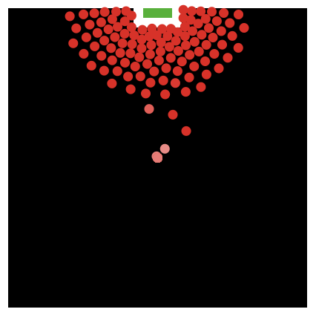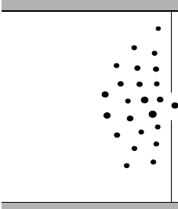
Figure 1a – Pushy Jerks Figure 1b – Helbing and Molnár[1]

Agents growing pushier
It is fairly easy to verify that agents grow pushier. The agents are programmed to change the shade of their color according to how pushy they are so it can be visually seen that the agents are indeed growing pushier.

Bartender service plan; service times and getting thirsty
This can also be visually verified to ensure that only agents near the bar counter are being served. The code for the two service plans are also small and succinct so it is also easily verified conceptually. The code for service times and customer inter-arrival times are short and succinct as well and are easily verified.

Results and Analysis
A BehaviorSpace analysis was done on the model, analyzing the distribution of average wait times while varying upper-pushiness, get-impatient?, and service-plan. Keeping all other values constant and keeping lower-pushiness at 0.5, values tested for upper-pushiness were 0.6, 0.8, 1.0, 1.2, 1.4, 1.6; values used for get-impatient? were true and false; values for service-plan were “random” and “waited-longest”. Having belligerence increase over drinks was not tested because the simulations are run for long periods of ticks so eventually, the population of agents with the maximum pushiness value will continuously grow until all agents are equally pushy, and will not provide any additional useful information. The BehaviorSpace simulations were run for 5000 ticks each before terminating.

Results for get-impatient? = false; service-plan = random
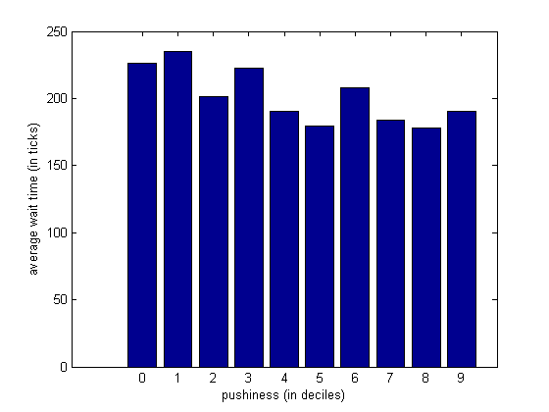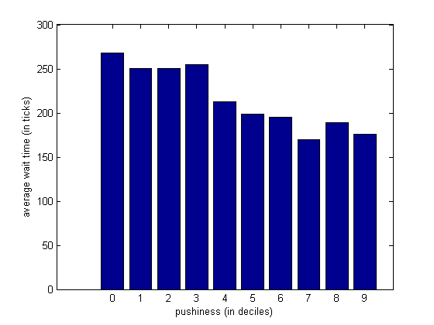
Figure 2a – upper-pushiness = 0.6 Figure 2b – upper-pushiness = 0.8
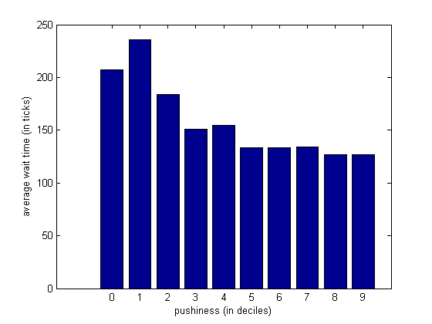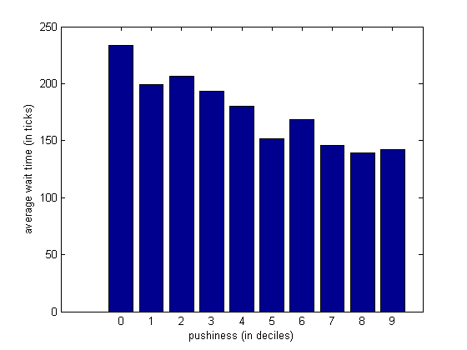
Figure 2c – upper-pushiness = 1.0 Figure 2d – upper-pushiness = 1.2
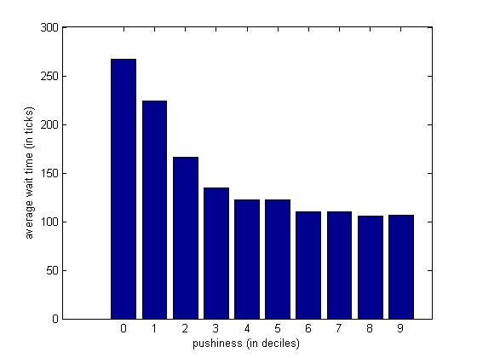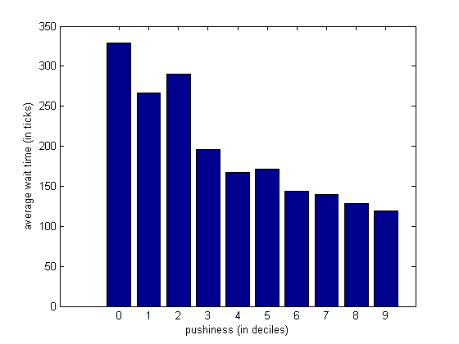
Figure 2e – upper-pushiness = 1.4 Figure 2f – upper-pushiness = 1.6

Average wait time of all agents as a function of upper-pushiness
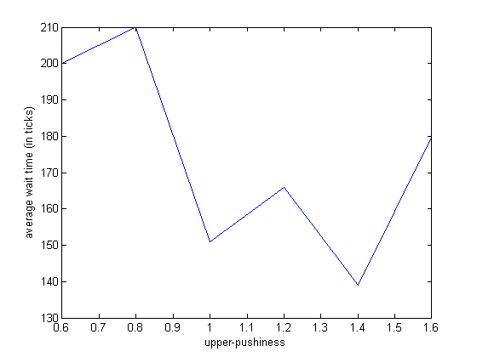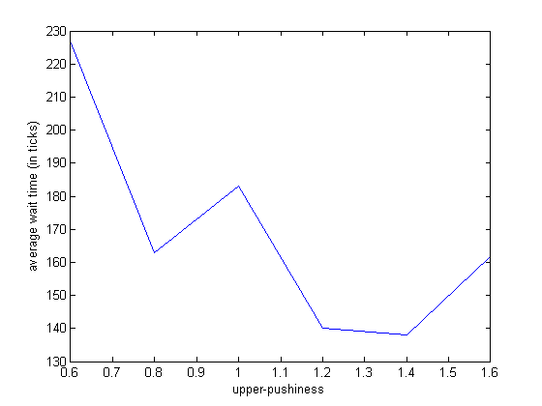
Figure 6a – get-impatient? = false; service-plan = random Figure 6b – get-impatient? = false; service-plan = waited-longest
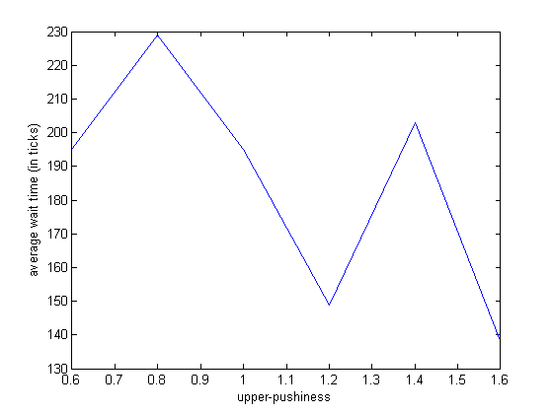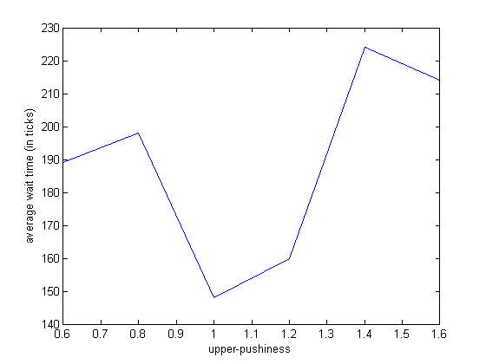
Figure 6c – get-impatient? = true; service-plan = random Figure 6d – get-impatient? = true; service-plan = waited-longest

Analysis
The results of varying get-impatient? and service-plan didn’t vary much from each other. See appendix A for the remaining 3 datasets. What was interesting about the results were that increasing the range of pushiness values greatly affected the distribution of the average wait times. The figures suggest that the distribution tends toward an exponential curve. For the higher upper-pushiness values, the difference between is rather large, with the pushiest agents spending around half the time waiting for a drink than the least pushy agents do.
What is surprising is that the average wait time of all agents do not follow any particular trend. Average wait times from a small number of trial runs before using BehaviorSpace suggested that the average wait time of all agents decreased as upper-pushiness increased but the BehaviorSpace data shows that the average wait times may not follow a predictable pattern. However, it is completely possible that the BehaviorSpace simulations may need to be run for longer periods of ticks and may need to be run multiple times for each configuration to gather more data.

Conclusion
After collecting some polling data on bar patron behavior and anecdotal evidence of how bartenders choose the next patron to serve, Helbing and Molnár’s social forces model was used and extended to model how crowds behave in bars. Poll data indicates that people tend to get pushier the longer they’ve waited to get a drink and shows a weak indication that they become pushier after they’ve had more drinks. Interviews with bartenders show that although bartenders try to make sure that no one is waiting too long to be served, some are not able to keep track of everyone on busy nights and are left to randomly choose people to serve.
Multiple simulations were run while varying the values of upper-pushiness, service-plan, and get-impatient?. It was found that as upper-pushiness increases, the distribution of average wait times for agents with varying pushiness values resembled an exponential curve, with the least pushy agents waiting the longest and the pushiest agents waiting the shortest. The difference between the average wait times of the two groups at opposite ends of the pushiness spectrum can even reach a 2:1 ratio, with the pushiest agents waiting half as long as the least pushy. The data for the average wait time of all agents for different values if upper-pushiness, however, does not indicate any trend require additional analysis.

References
[1] D. Helbing and P. Molnár, “Social force model for pedestrian dynamics”, Physical Review E 51, 4282-4286 (1995)

Appendix A.1: Results for get-impatient? = false; service-plan = waited-longest
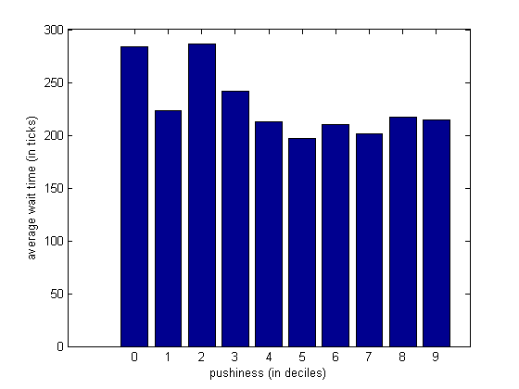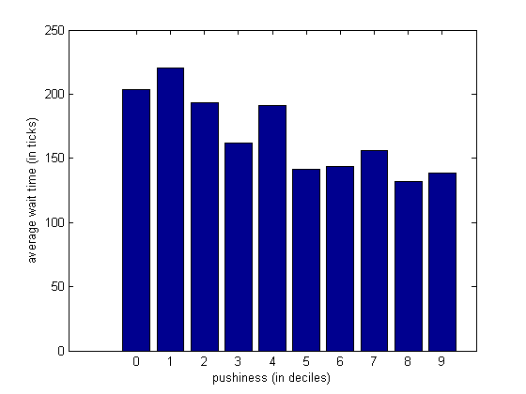
Figure 3a – upper-pushiness = 0.6 Figure 3b – upper-pushiness = 0.8
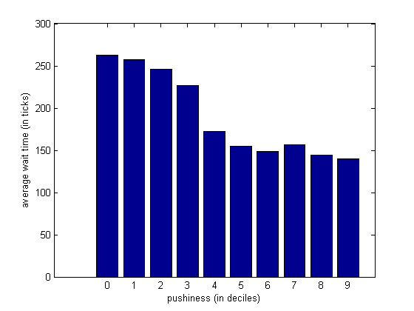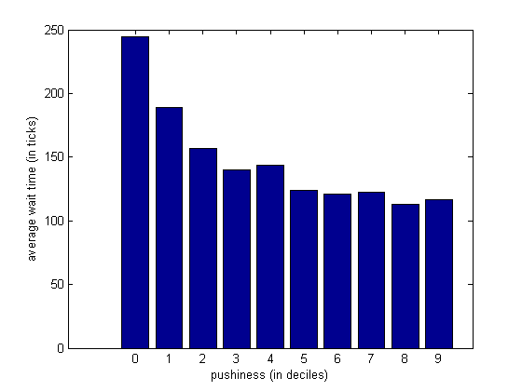
Figure 3c – upper-pushiness = 1.0 Figure 3d – upper-pushiness = 1.2
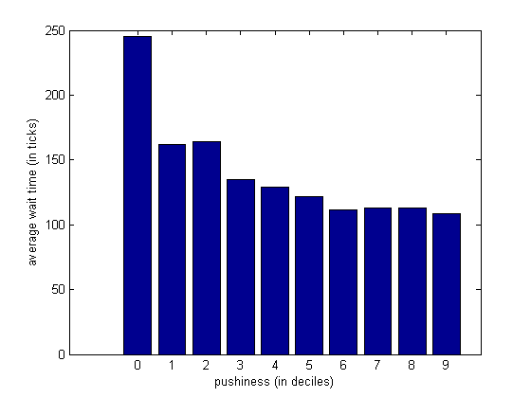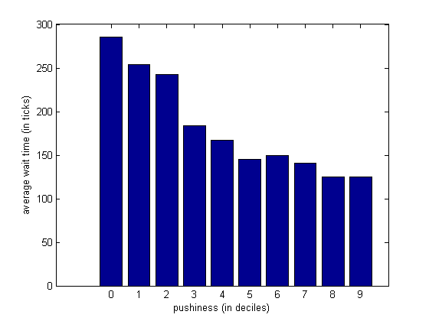
Figure 3e – upper-pushiness = 1.4 Figure 3f – upper-pushiness = 1.6

Appendix A.2: Results for get-impatient? = true; service-plan = random
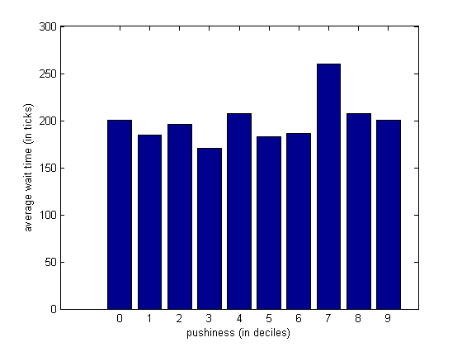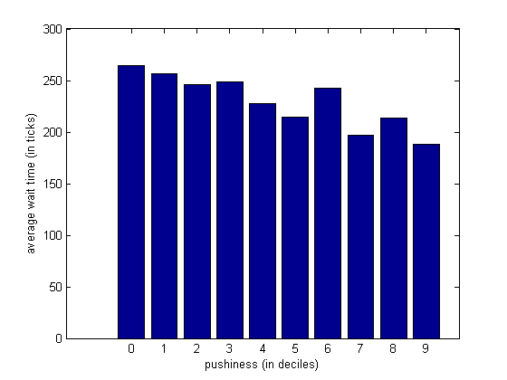
Figure 4a – upper-pushiness = 0.6 Figure 4b – upper-pushiness = 0.8
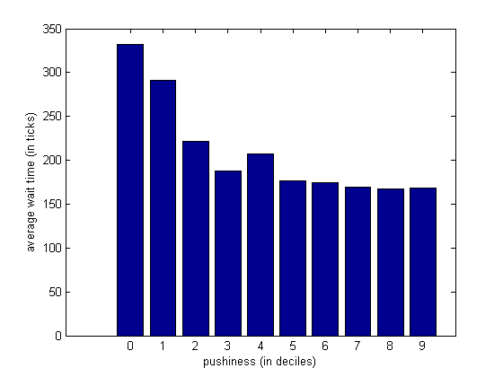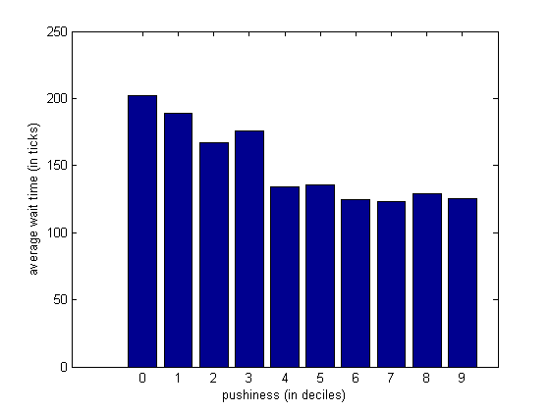
Figure 4c – upper-pushiness = 1.0 Figure 4d – upper-pushiness = 1.2
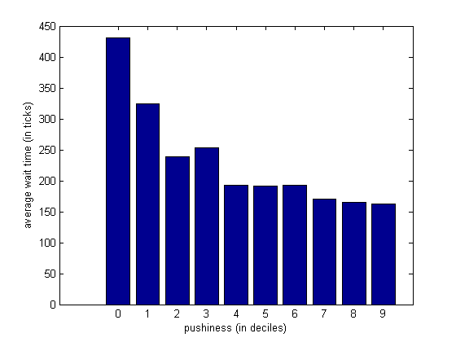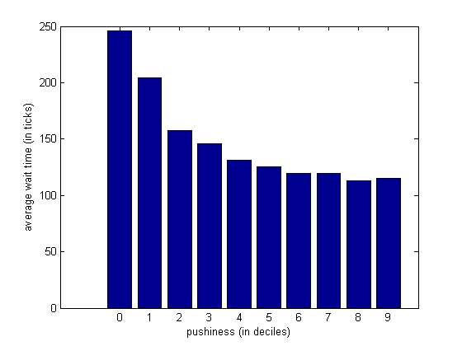
Figure 4e – upper-pushiness = 1.4 Figure 4f – upper-pushiness = 1.6

Appendix A.3: Results for get-impatient? = true; service-plan = waited-longest
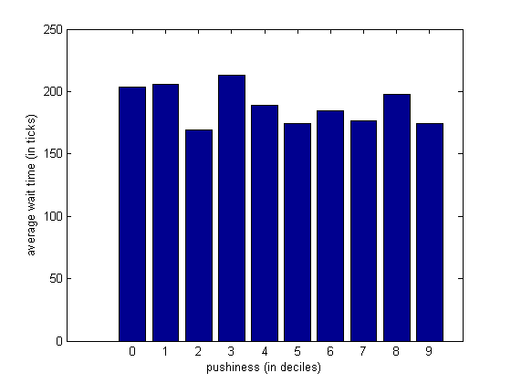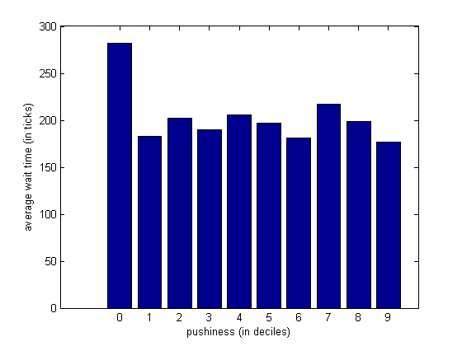
Figure 5a – upper-pushiness = 0.6 Figure 5b – upper-pushiness = 0.8
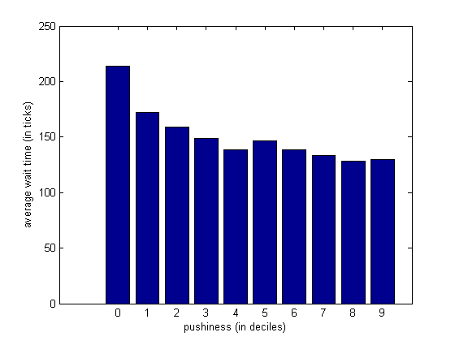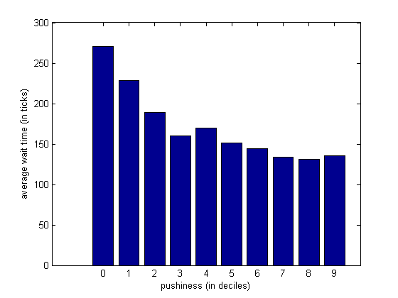
Figure 5c – upper-pushiness = 1.0 Figure 5d – upper-pushiness = 1.2
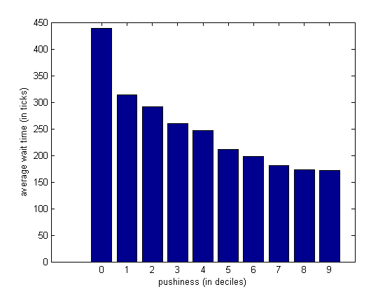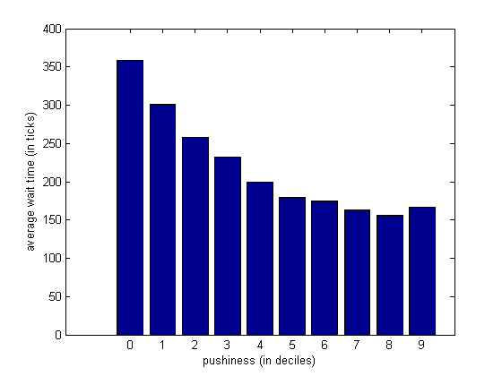
Figure 5e – upper-pushiness = 1.4 Figure 5f – upper-pushiness = 1.6

