Yash Siddhartha | [Course Title] | [Date]
Going ViRAL
Method or Madness?

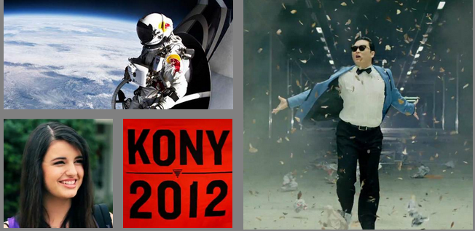

Going Viral

Problem Statement:
I plan to design and implement a model that would allow simulation of some form of online content across a network of people, i.e. computers. The goal of this model is to figure out how and why this content goes viral. Virality would be characterized by a large spike in the number of views/shares of said content over a short period of time. There are many theories that explain how content goes viral. I would like to take a MAM-based approach to explaining virality and see how that correlates to the models I find explaining it with other approaches.

Guiding Questions
What leads to people sharing content as opposed to just viewing it?
What conditions are required for the domino effect to come into play?
How effective are viral ad campaigns?

Theory
The challenging part is understanding why some content gets popular without necessarily going viral. At this point, it is important that we have a definition of virality to contrast with the idea of just popularity:
- Lots of shares between people
- Build up to a critical mass after which velocity of sharing goes up significantly
- Not necessarily limited to a wide audience. Can be targeted to smaller audiences.
Jonah Berger, an associate professor of marketing at Wharton Business School, wrote a book called “Contagious: Why things catch on” and is considered one of the leading thinkers in the field of viral marketing. In his view, there are 6 things that make content go viral:
- Popularity of the basic idea behind the content
- Triggers / Daily reminders of the product/idea
- Visibility of product/idea
- Usefulness of content
- Emotional Reaction
- Great story (jonahberger.com)
Implementation
Agents:
Agents would be the single computers/users in the world who use the internet.
Interactions
This is where the model gets complicated. Every agent is connected to some other agents and they form communities in some sense. All communities are inter-linked through one or more agents, as one would expect with the internet.
Agent rules would include:
- Look at said content
- Agents will be represented as gray spheres (similar to the virus model) and then will change color – yellow upon viewing the video and red upon sharing it.
- Agents who do not share the video after multiple views will turn dark yellow until/unless they do
- Agents will have personality “traits” that will map to the video and affect their willingness to see/share it
Content Behavior
- Content can be introduced by the user into different parts of the network built.
- Content can be “created” by the user to have different characteristics – funny, happy, sad, stupid, repetitive and so on.
- Content introduction can be timed and/or promoted. Essentially this is to account for corporations trying to make ads go viral on Youtube or similar phenomena
In many ways, I envision this to be somewhat similar to the “Fire” model with the random sparks built in (in a sense –connections within networks)
The spread of the video is contingent on a number of factors and we can track its spread/virality based on how quickly users adopt it and what percentage of them end up sharing it.
At the first tick, I would have the video get released- either on a single node or on multiple nodes and then have agents view it for a duration of one tick and then decide whether or not to share it. They may choose not to share it the first time but will share it if they see it often enough. It’s unclear if that could lead to a viral phenomenon or not.
There’s also content that might go viral among a niche of people. I’m guessing this could be a quick localized spreading of the content before it gets put out once it has effectively reached its target audience (gamers, underground music fans etc)

Why Netlogo
I think virality is an incredibly interesting concept and all the data has been broken out into various theories of how videos get viral but I haven’t found anything with a MAM approach thus far and would like to approach it in that sense. Will just a certain kind of video with the right kind of backing go viral? The evidence suggests so, thus far at least.
The emergent behavior I’d like to see would correlate with the different tenets set out by Prof. Jonah Berger and give me viral behavior for that kind of content as well as some empirical evidence laid out by marketing websites.
Analysis
Analyzing this model will involve the use of real life examples of content that has gone viral, based on subjective ratings of the emotions this media is intended to evoke and manipulation of certain parameters across the video.
- Friday
“Friday” was adjudged by people to have the following characteristics:
vfunny – 5, vanger – 4, vsad – 0, Repfreq –10, vutil –2
Friday was marketed rather aggressively, so “rounds”, “campaignlevel” will be high and “target?” on. I will do a run with “homophily?”, “supernode?” on and “randomsparks?” as well for a baseline. Then we will vary these parameters on the same structure, using “hold?”
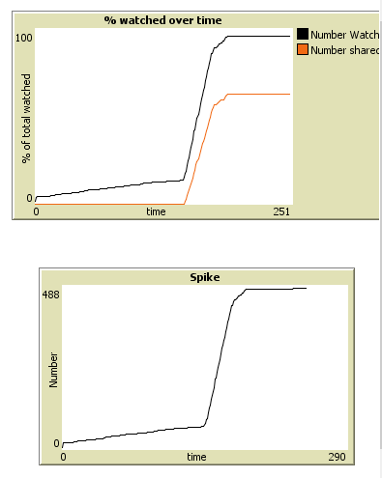
First Run
Turning “target?” Off

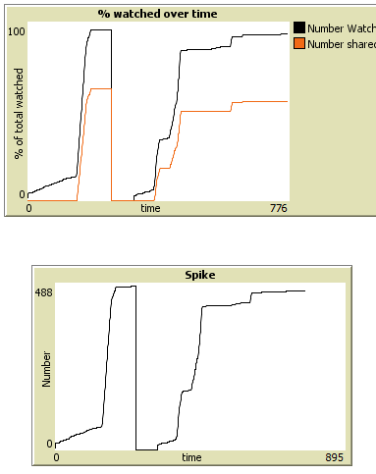

Figure: Turning “target?” off on the same social network changes how this video goes viral rather surprisingly, though it makes sense.

To clarify, “target?” aims the video at people with high affinities to emotion –funny, anger- thus, making them more likely to share.

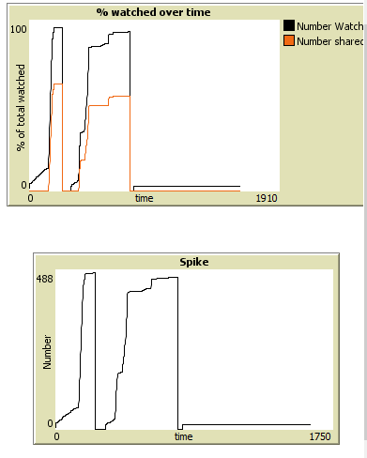
Randomsparks? Off at the end- Makes sense that the video no longer takes off – partly an effect of homophily and how the network is set up.

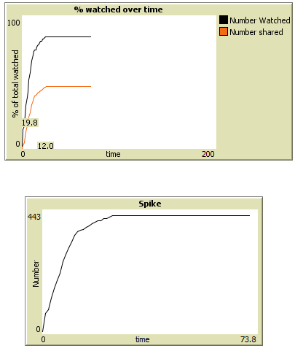
Figure 4: “Homophily?” off, “target” off and “randomsparks” off gives me a very interesting behavior. The video spikes almost instantly to a very large number of views. (Note: Had to be a different setup because “Homophily?” is pre-setup. Results stayed consistent across the model though.

Based on these 4, there are some interesting insights to be made.
- Homophily, to some extent, appears to be limiting the spread of the video very far and wide. Along with “target?” it appears to be trapping the video within a certain portion of the network.
- Once I put “randomsparks?” into the mix, it allows for the video to be seen outside these little networks that forms.
- This gives me a result much closer to the reference pattern that one thinks of with viral videos. The multiple views of videos (or interactions with content) also plays a large part in the way content goes viral. If I take that out, I either have the content skyrocket to virality or barely budge.
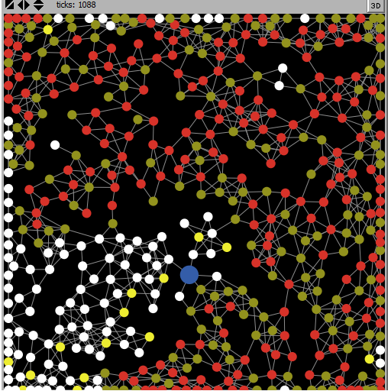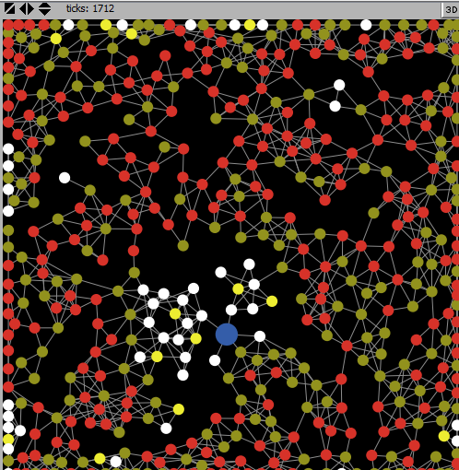
Figure: Randomsparks? Hits the video. (over a few hundred ticks effect)

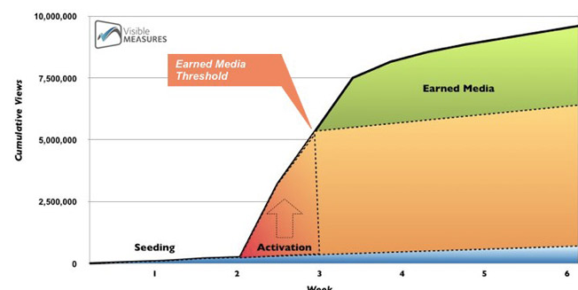
Figure: Reference Pattern – Adage.com

Compares quite well to Reference Pattern
I’m not entirely sure whether the % change over time is a better indicator than just the number on a small-scale. I kept both just to be sure.
Supernode?
A lot of times, a celebrity will re-tweet a video or other content or post something about it on Facebook and this sparks virality. This was the case with Justin Bieber’s post on “Call Me Maybe” as well as Jimmy Kimmel’s tweet of “Double Rainbow” (200 views -> 31m now, NYT). So, I simulated the existence of one supernode in my code to see how it would affect things. I found that the supernode actually better simulated virality than the lack of one (the sudden spike in views after seeding is definitely helped by this).
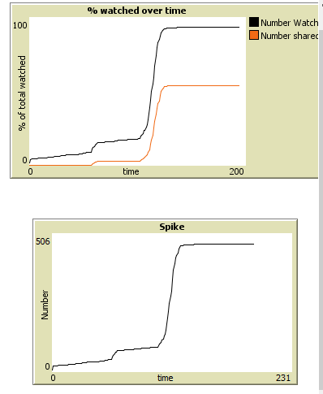 With Supernode

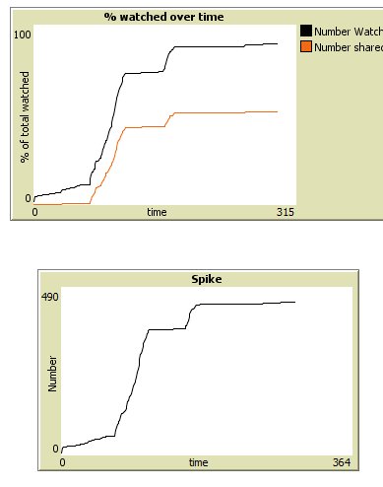
Without Supernode – not quite as smooth transitions to virality
Rounds
With rounds =0, i.e. no marketing campaign, a video will take a lot longer to seed and activate just because there are less initial views, no matter the content. All of the momentum to be generated is via randomsparks.

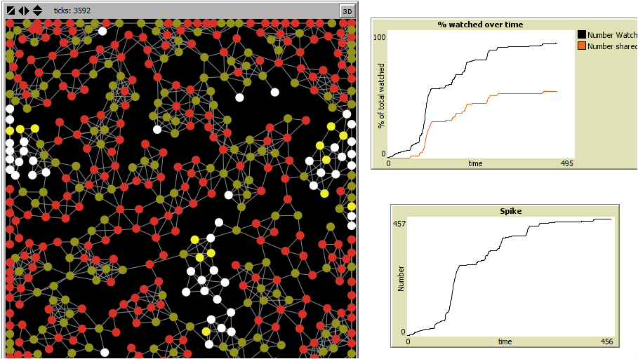
This took double the number of ticks to get to a decent level of views. In all likelihood, the “buzz” around it would have died down. “Randomsparks?” stops past a certain tick count, but it doesn’t always constrain properly, which is why it kept adding views for so long.
Emotions
According to Prof. Jonah Berger’s research on virality and viral emails:

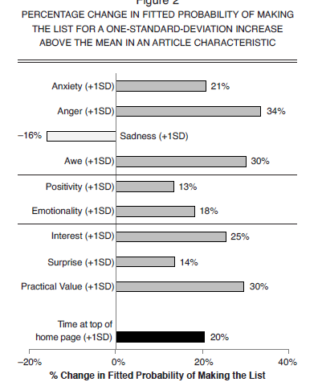
This empirical evidence is a little difficult to mimic since it is based on human coders’ perception of emotions. There are also a lot more indicators than I chose to include in my model. I condensed many of them into a single emotion. (vutil: interest, surprise and practicality)
Furthermore, this doesn’t seem to take into account the different levels of emotion each person might be prone to. I didn’t make that a large distribution, but I definitely included that in my study, whereas this appears to be more objective.
But, as you increase the scale on any of the emotions displayed, you will see the video going viral faster and easier (assuming constant features for spread). You will notice that videos with humor go viral easier than others. This is because humor is the easiest way to get a video to go viral. (Techopedia)
Limitations of the Model
- The model mimics viral behavior pretty decently, but is not the most robust in its current form. Perhaps needs some constraining as to the user inputs on content characteristics
- Not everyone who gets the content shared with them should necessarily watch it. I meant to implement that as an enthusiasm factor in the sharing, kind of like a strength of recommendation, but spent too much time tuning other parameters.
- More degrees (more smoothness) of emotion in the user would probably allow for better curves being plotted.

- A better world- Is there a good way to take the internet and condense it into a smaller network? I'm not sure how one would go about implementing that though.

- Understanding the decision making itself better. I know what factors affect decision making, but there's no clarity on the actual decision made by agent. I just chose parameters and kept tuning till the model gave me answers that made sense (as long as parameters were also reasonable)

- This model is better at explaining videos going viral as part of a concerted marketing campaign than the random momentum buildup from unintended viral videos. However, the video does show sudden spikes even with just randomsparks and no marketing. It’s just not as continuous as I’d like it to be. This might actually be understandable with these kinds of content though.
Conclusions
- Viral ad campaigns are an effective tool for making videos go viral. They help generate the necessary buzz around a video to help it go viral. (see Figures after conclusion)
- There is something to be said for perhaps targeting different kinds of people with content because homophily does appear to limit widespread virality to a large extent.
- The domino effect really seems to come into play once the content has made it around the world and is then brought up again somehow because people are still affected by it the second time around. This also explains the slow-burning virality of some random scontent. The effect of nostalgia or having seen it before can lead to sharing and suddenly spark a domino effect (“viral reactivation” – adage.com)
- Surprisingly for me, I found “randomsparks” is the most important part of this model. Whether they’re created as a result of great branding, great positioning, a spot on Youtube’s recent videos or any other reason, it’s the difference between going viral and not.

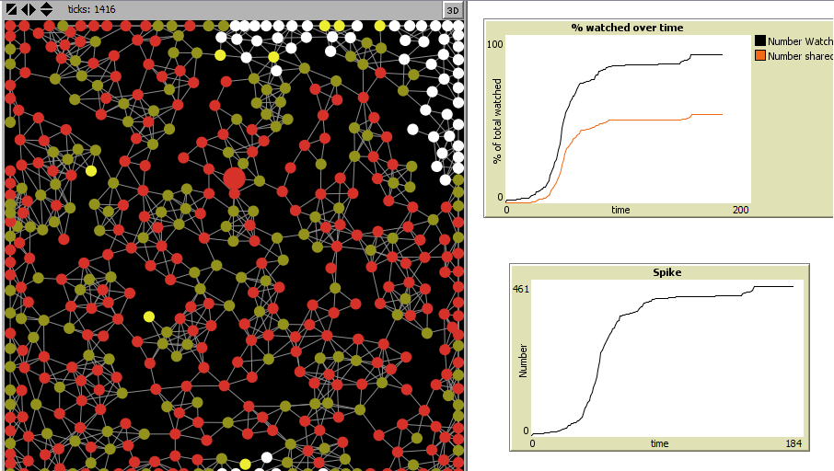
Without “target?”
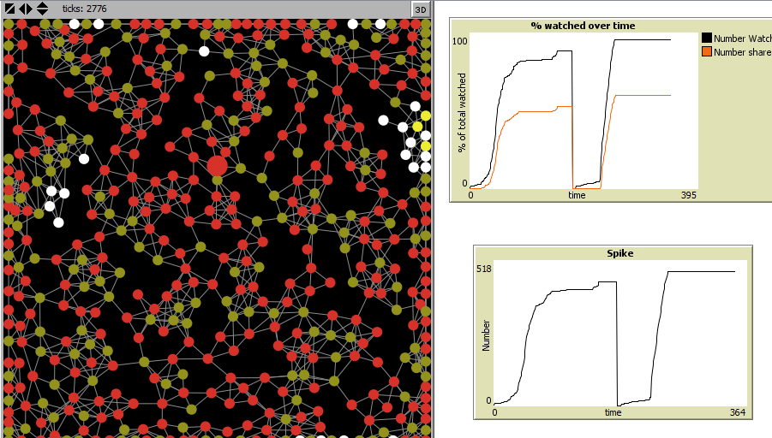
With “target?” after “hold?” used.
Sources
CREDIT: Thanks for all the help, David and Arthur (especially for introducing me to the concept of homophily). Thanks to all the TAs and Prof. Uri for a great class.
Berger, Jonah A., and Katherine L. Milkman. "What Makes Online Content Viral?" By Jonah A. Berger, Katherine L. Milkman. N.p., n.d. Web. 10 June 2013. <http://papers.ssrn.com/sol3/papers.cfm?abstract_id=1528077>.

"Virality Explained." Virality Explained. N.p., n.d. Web. 10 June 2013. <http://www.viralityexplained.com/>.

"Q&A: Jonah Berger, Wharton Marketing Guru, on What Makes Things Go Viral."SmartPlanet. N.p., n.d. Web. 10 June 2013. <http://www.smartplanet.com/blog/pure-genius/q-a-jonah-berger-wharton-marketing-guru-on-what-makes-things-go-viral/10010>.

"How to Write the Perfect Blog Post." Social Triggers RSS. N.p., n.d. Web. 10 June 2013. <http://socialtriggers.com/perfect-blog-post/>.

Berger, Jonah. "Why Do Things Go Viral? (PHOTOS, VIDEO)." The Huffington Post. TheHuffingtonPost.com, 14 May 2013. Web. 10 June 2013. <http://www.huffingtonpost.com/jonah-berger/why-do-things-go-viral-ph_b_3275166.html>

"Viral Video." Techopedias. N.p., n.d. Web. 10 June 2013. <http://www.techopedia.com/definition/26863/viral-video>.

Berger, Jonah. "Contagious: Why Things Catch On." Jonahberger.com. N.p., n.d. Web. 10 June 2013. <http://jonahberger.com/wp-content/uploads/2013/03/Contagious-Framework-STEPPS.jpg>.

"You Didn’t Make the Harlem Shake Go Viral-corporations Did." Quartz. N.p., n.d. Web. 10 June 2013. <http://qz.com/67991/you-didnt-make-the-harlem-shake-go-viral-corporations-did/>.

"The Secret Strategies Behind Many "Viral" Videos." TechCrunch RSS. N.p., n.d. Web. 10 June 2013. <http://techcrunch.com/2007/11/22/the-secret-strategies-behind-many-viral-videos/>.
Weng, Lillian. "Virality Prediction and Community Structure." Iu.edu. Http://mypage.iu.edu/~weng/virality.html, n.d. Web. 10 June 2013.
"How to Make a Video Go Viral | Technobabble 2.0." Technobabble 20. N.p., n.d. Web. 10 June 2013. <http://technobabble2dot0.wordpress.com/2008/03/18/how-to-make-a-video-go-viral/>.

Miller, Claire C. "Cashing in on Your Youtube Video." Nytimes.com. New York Times, n.d. Web.

"Top 10 Viral Video Advertisements of All Time." Advertising Age The Viral Video Chart RSS. N.p., n.d. Web. 10 June 2013. <http://adage.com/article/the-viral-video-chart/top-10-viral-video-advertisements-time/229504/>.

"Samsung, Wieden & Kennedy Rule Ad Age's 2013 Viral Video Awards." Advertising Age Special Report Digital Conference RSS. N.p., n.d. Web. 10 June 2013. <http://adage.com/article/special-report-digital-conference/samsung-wieden-kennedy-rule-ad-age-s-2013-viral-video-awards/240900/>.

