Competing Technologies in the Mobile Market
A competition between two mobile giants: Apple and Blackberry
Felix Hu
Abstract
This model explores the scenario of two technologies competing for a limited resource: customers. The technologies will be Apple (iPhone) and Blackberry, and the market will be the American mobile market. Predictable and consistent behaviors and patterns emerge from a simple set of rules in the Agent Based Mode.

Summary
This model explores the scenario of two technologies competing for a limited resource: customers. The technologies will be Apple (iPhone) and Blackberry, and the market will be the American mobile market. In this model, customers enter into the market over time and make their decision based on a set of personal preferences. Each company has income based on the number of customers currently using their technology, and the user chooses how each company invests that income.

Income can be invested into either marketing, or research and development. The agents in this model represent consumers. The goal of this model is to explore the effects of spending on market share.

What can be learned
In the highly competitive mobile market, decisions on spending can have a drastic effect on the market share. The outcome of two competing technologies can be difficult to predict, especially considering the cumulative advantage either party can quickly gather. If one technology has an early lead in customers, that technology will have more initial income than the other, which may secure an insurmountable lead for the future.

With the hard to predict nature of competitive forces, it may be in a corporation’s interest to build accurate models of their customers, and incorporate its decisions into this model so that they may make better decisions. This model predicts the market share of two generic technologies in a generic market. However, despite these general parameters, this model sets the foundation for further customization specific to each corporation.

This model answers basic questions such as:
- how should a corporation distribute its resources:
  - when it is just entering a market?
  - after it has been in the market for some time?
- what causes an equilibrium of two coexisting technologies?
- what causes one technology to completely die out?
- how does the amount of customers affect how companies should invest their resources?

Implementation/Rationale

Setup
An initial amount of customers are created
Distribution between iPhone and Blackberry customers is controlled by a slider. iPhone customers are agents represented by orange circles, and Blackberry customers are represented by magenta circles.

An initial environment of marketing influence is created.
Marketing will initially be split roughly 50% iPhone and 50% Blackberry. Marketing influence is represented by the color of the patch. The blacker the patch is, the more influence Blackberry has in that patch. The lighter and bluer the patch is, the more influence iPhone has in that patch.

It is perhaps useful to think of patches as neighborhoods, and the agents in that patch as agents that reside in those neighborhoods. In real life, customers would travel around, but in this model they do not. I did not feel that there was a need to have customers travel around, as the cumulative influence customers feel from marketing can be represented on a macro level by turtles in a patch. However, if I were to try model turtles on a realistic individual level, I would have them walk around. This model is more about the exploration of what happens as a general trend, not about what individual turtles choose.

Each customer that is created is given three personal preferences
These preferences represent how important each factor is to that particular customer. The three preferences are: susceptibility to marketing, attraction to technology, importance of what friends are using.

3 normally distributed random numbers represent these preferences. It is impossible to accurately represent each individual customer, but with a normal distribution of three random numbers, the representation this has on the general population is sufficient. One may argue that humans are in general more susceptible to marketing than they are actual technology, but this is difficult to quantify, and it makes sense to instead stick with the same normal distribution for each of the three preferences.

Each customer has an initial set of friends.
Whether or not a customer has friends is random, and the amount of friends they have is also random. Friends are not represented visibly.

I did not make a slider to control friendship, only an on-off switch for whether or not customers have friends. This is because the control space of the model was becoming too cluttered, and since it was not something that companies can control, it is irrelevant to this model. Friends are not represented visibly by links because it makes the display far too cluttered, and are also irrelevant to this model front and back end.

Each tick
Both technologies gain an income.
They gain one “dollar” for each customer currently using their technology.

This is to simulate the benefits garnered by each customer. By having customers, technologies gain more value in the stock market, benefit from people using their technology (Google vs. Bing, etc.), and are subsidized by carriers. This also accounts for the profit made from selling the phone.

Both technologies spend their income.
They invest their money based on a set of sliders controlled by the user. They either spend it towards marketing, or research and development.

These are two main sections in which companies spend their money: R&D and marketing. Thus, this is a fair representation.

Money spent on marketing will increase the influence of one patch.
This patch will increase in color by 1 point, up to 109, if Apple is paying for the marketing. The patch will decrease in color by 1, down to 100, if Blackberry is paying for the marketing. The cost of marketing will remain.

The color only changing by one per spending represents the difficulty of dominating one area completely with only one technology. The world is immense, and the opportunities to advertise are even more immense. The cost of marketing remains the same, but this is clearly not the case in the real world. More densely populated areas are much more expensive to advertise in. However, because the customers in this model do not clump or form groups, the cost of marketing in each cycle remains the same. On a macro scale, this has the same affect.

Money spent on technology will increase the technology.
This is represented by a variable for each company. The cost increases as the technology for each company increases, if the increasing-tech-cost? switch is activated.

Technology is also fairly difficult to quantify. However, for this model, I am assuming that both models are spending their money on research and development intelligently, and assuming that the company that spends more on technology will have a product that in general appeals to the technology-loving consumers more. The cost for technology increases as time goes on. This is because as technology becomes more advanced, it becomes more difficult to increase the technology linearly.

New customers are introduced into the model.
Customers are introduced using an inverse exponential function, if the option is activated. Otherwise, customers are introduced linearly. Customers are given friends, their own set of preferences, and they choose a technology based on those preferences.

The inverse exponential function represents the population’s reaction to a newly introduced technology. For the first few quarters, customers adopt it at a linear rate. As time passes, the amount of customers who adopt the technology begins to taper off, until there are barely any new adaptors of the technology.

Customers with expired contracts re-choose their phone.
Customers, every 4 years (default setting which can be changed), remake their decision.
Their personal preferences do not change, but since the environment and their friends may have changed, their decision may be different than their decision years ago.

Customers choose their phone by a series of simple decisions. Customers have three preferences, each represented by a normally distributed random number. They only factor in one of these preferences when making their decision, and the one is determined randomly, with preferences with greater numbers being favored. If the customer considers what their friends are using, the customer will be more likely to choose the technology that most of their friends are using. If the customer is attracted to technology, he will choose whichever phone is more technologically advanced, with no randomness—the phone with better technology number will win. If marketing is what the customer prefers, the decision will be made based on the color of the patch they are on. The phone with greater marketing influence will have a higher change of winning the customer’s choice.

Again, this is not an accurate representation on a micro level, as customers in real life factor in all their preferences when making their decision. However, I feel that this is a reasonable reduction for the macro level. These preferences are also reductions, as there are much more preferences that go into a purchasing decision. I feel that these are the main three. Preference of technology is not made random because I am making the assumption that people who have a preference for technology will buy the phone that objectively has the better technology. Marketing and friends is affected by a lot more random factors, such as which friends you are more close with, and which type of marketing you are more susceptible to. For example, you may not care about the Superbowl ad, but care more about an internet forum ad.

Analysis
To begin the analysis, we examine how the market share changes when we gradually increase the amount of money Apple invests into marketing while keeping Blackberry’s spending the same: half its income spent on marketing, and the other half spent on research and development. Friends was on, as well as inverse exponential growth as well as increasing tech costs.

For all runs: Blackberry spends 50% on research and development, and 50% on marketing.

Apple spends 50% on research and development, and 50% on marketing:

Run 1:
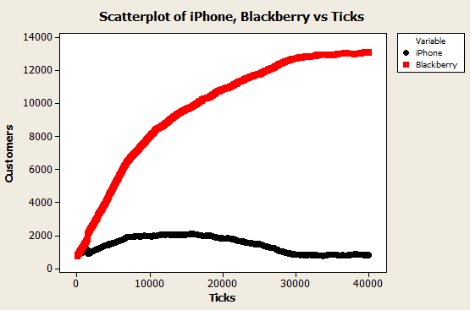
iPhone marketing influence at end 0%

Run 2:
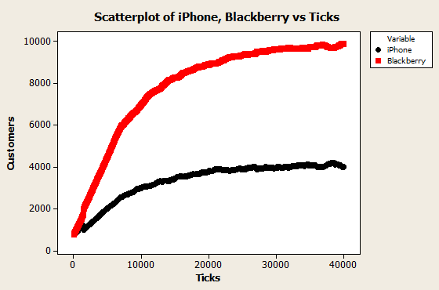
iPhone marketing influence at end: 44%

Run 3:
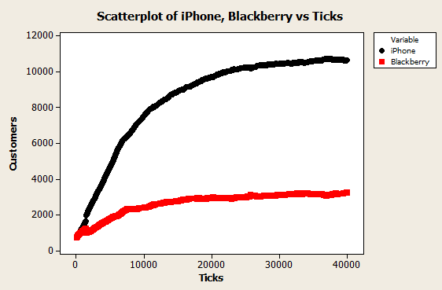
iPhone marketing influence at end: 56%

Comments:
The power of the cumulative advantage is clear here. These experiments started with the same variables, yet there were drastically different results. The first run had Blackberry completely in the lead; the second run had Blackberry in the lead, but not as dominant; the third had iPhone in a dominating lead. Marketing influence for iPhones also were erratic.

Apple spends 40% on research and development, and 60% on marketing:

Run 1:
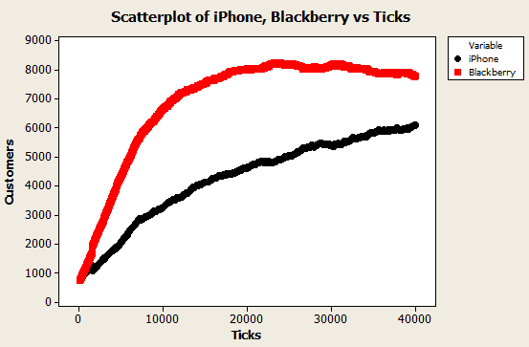
iPhone marketing influence at end: 72%

Run 2:
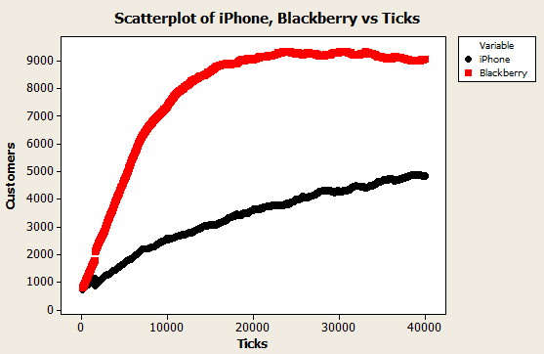
iPhone marketing influence at end: 56%

Run 3:
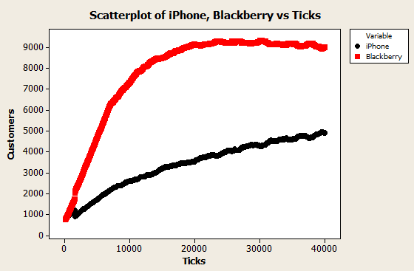
iPhone marketing influence at end: 56%

Comments:
By simply making Apple’s spending habits slightly different from Blackberry’s, the results are much more predictable. This pattern persists, as iPhone’s spending habits becomes apart from Blackberry’s, and from now I will only include one run per variable change. Blackberry gets the customer lead still, but it is far less drastic, and iPhone’s marketing influence is slightly greater.

Apple spends 30% on research and development, and 70% on marketing:
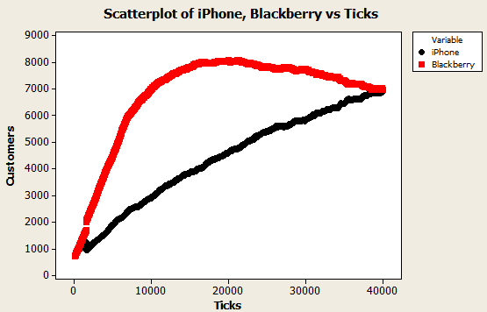
iPhone marketing influence at end: 85%

Comments:
A pattern is emerging: when Blackberry spends more money on research and development, it initially gathers much more customers than iPhone, but slowly tapers off as the marketing influence grows for iPhone. All three runs had iPhone and Blackberry customers converging around 40,000 ticks, with iPhone having 85% marketing influence.

Apple spends 20% on research and development, and 80% on marketing:
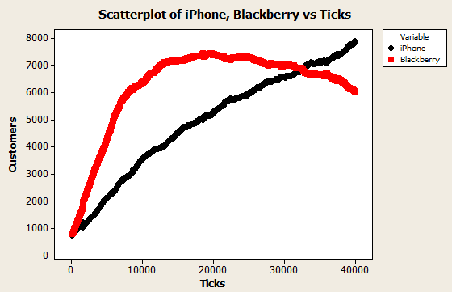
iPhone marketing influence at end: 95%
iPhone marketing influence at intersection: 85%

Comments:
With this setup, iPhones surpass Blackberries, and had 2000 more customers at 40,000 ticks.

Apple spends 10% on research and development, and 90% on marketing:
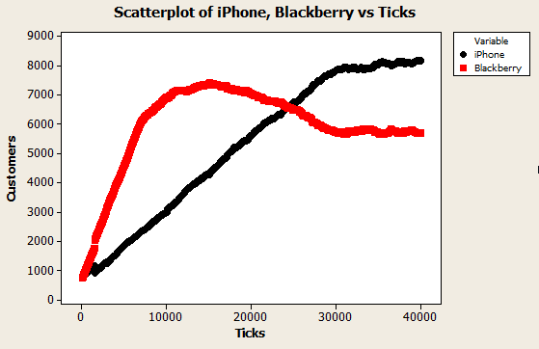
iPhone marketing influence at end: 99%
iPhone marketing influence at intersection: 85%

Comments:
Again, the iPhone marketing influence at the intersection of iPhone and Blackberry is at 85%. A clear pattern is arising. This time, the marketing distribution is completely dominated by iPhone at the end. The intersection happened quicker, and Blackberry has 3000 less customers than iPhones.

Apple spends 0% on research and development, and 100% on marketing:
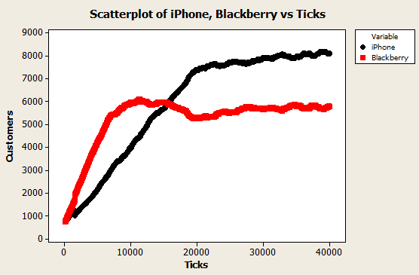
iPhone marketing influence at end: 100%
iPhone marketing influence at intersection: 85%

Comments:
This run is fairly unrealistic, as iPhone does not spend any money on research and development, but rather all their income on marketing. Yet they still surpass Blackberry at roughly 20,000 ticks, and proceeded to by 3000 customers ahead of Blackberry.

From the results obtained by only increasing iPhone’s spending on marketing, it seems clear that spending on technology initially attracts more customers, but eventually does not hold up. It would make sense for a company then, to first spend money on technology, and after a certain time, to then spend money on marketing. Behavior space runs much slower than simply running the model, perhaps because the computer it is run on has a slow hard drive. Thus, in the interest of time, I will just run the experiment manually.

iPhone first has 100% in technology, then 100% in marketing after 5000 ticks; Blackberry remains at 50%:

Graph
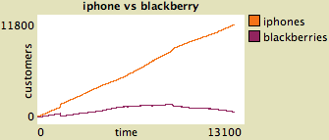

World


Comments:
The result is very clear. iPhone pulls ahead with its initial investment into tech, and with the customers (income) it acquires from the start, it can build up its marketing much quicker than Blackberry. Even though after 5000 ticks, iPhone spends 0% on research and development, it is very difficult for Blackberry to catch back up, even in technology. This is because with the limited customers (income) that Blackberry has, it cannot upgrade its technology fast enough. Eventually, there were no Blackberry customers.

So this raises the question of what can Blackberry do when it is behind, to get ahead? Perhaps Blackberry can put all their resources into technology, instead of spending half of their money on marketing, because they clearly cannot compete with iPhone for marketing.

iPhone first has 100% in technology, then 100% in marketing after 5000 ticks; Blackberry starts at 50%, and goes to 100% in technology after 3000 ticks:

Graph:
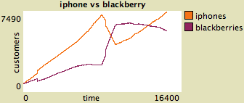

World:


Comments:
Blackberry began putting all its resources into technology when iPhone had a lead. This gave Blackberry a huge influx of customers as their technology surpassed iPhones, and all new customers and iPhone customers which chose the iPhone because of its technology switched to Blackberry. However, since iPhone already had a lot of customers, it had the power to completely dominate the marketing environment, which eventually swung the market share back into its favor.

What could Blackberry have done in this situation to secure its lead after it surpassed iPhone in customers? The obvious answer would be to immediately increase its marketing after it surpasses the iPhone in customers. Let’s see if this works.

iPhone first has 100% in technology, then 100% in marketing after 5000 ticks; Blackberry starts at 50%, and goes to 100% in technology after 3000 ticks, then 100% in marketing after it surpasses the iPhone in market share:

Graph:
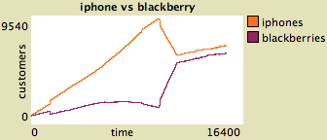

World:


Comments:
Blackberry still did not surpass iPhone in market share, but their market share does remain extremely close. Blackberry was unable to pull ahead in market share because of the lead that iPhone had from being initially ahead. By the time Blackberry put all its resources into marketing, iPhone already had most of the patches in their favor, and it was difficult to battle with iPhone’s marketing campaign unless iPhone for some reason decided to reduce the funding for marketing.

So, what can iPhone do, to secure its lead and make it not close? It makes sense that if iPhone has a customer lead, all it has to do is exactly mimic Blackberry’s spending to continue its lead, as it will always have more money to invest. Let’s try this.

iPhone first has 100% in technology, then follow Blackberry through a series of random changes in spending percentage; Blackberry starts at 50%, and goes to 100% in technology after 3000 ticks, and randomly changes its spending percentages after that:

Graph:
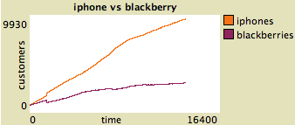

World:


Comments:
Blackberry changed its spending habits many times in this run, but iPhone followed its plans exactly. The graph shows the correct result, that iPhone continuously remained ahead of Blackberry, and its lead only grew. As can be seen in the world, the marketing influence is more stratified, but iPhone has a clear lead.

How does decreasing the amount of adaptors of the technology change how companies should invest their money? Let’s try it and see.

Maximum new adopters: 1500; iPhone spends 80% on research and development, Blackberry spends 70% on marketing:
Graph:
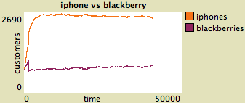

World:


Comments:
With the amount of customers so low, marketing does not seem to have a visible affect on market share. iPhone secured its lead early on by being more technologically advanced, and maintained it throughout the run. Blackberry does not have enough customers to make a difference in marketing, as even after 50,000 ticks, marketing influence remained 50% for iPhone.

Conclusion
From the experiments run, the best way of gaining an advantage in market share is to first put money into research and development, then change into marketing once there are enough customers to fund the marketing. This makes a great deal of sense, and is something that we can observe in many major corporations around the world. It is also apparent that it is very difficult to regain market share once one company obtains an advantage, as that company has more income, and thus more spending. However, this is an ideal world, and in the real world most corporations have much funding, as they have multiple products to gather income from. That is why it is possible for iPhones to have initially stolen market share from companies such as Nokia, and why it is possible for a company such as Google to now take market share from iPhone.

The cumulative advantage is very apparent, and can be a problem reflected in the real world. Since people who have studied economics head most corporations, it is very likely that they will employ similar allocations in spending. This creates situations where it is very difficult to predict which company will rise ahead in market share.

Density plays a large role in how effective marketing is. If a technology is not very popular, it makes much more sense to instead appeal to people who are attracted by advanced technology, as in low number scenarios research and development has proved to be the more efficient place to spend money.

This model only attempts to model the complexity of the mobile market. There are many intricacies (some described in the Info tab of the model) that are not modeled, and can play a significant role in determining market share. However, this model does show that patterns do indeed emerge from simple rules: for example, when one technology’s market share surpasses the other, the marketing influence is generally around 85% for the winning company. This model provides a baseline for how competing technologies can potentially play out, and can be made more realistic and useful by adding in data taken from the actual world.

