Jacob Samson
Deep Neural Network Architectures and Dropout Learning Visualization
Machine learning has become a field in which practice consistently outpaces understanding. Not only are many machine learning algorithms extremely hard to formalize at the scale seen in industry, but the utility gained by the empirical improvement of almost any learning algorithm is enormous, and hence well-incentivized. As a result, many of the optimizations and “tweaks” made to machine learning algorithms in practice are not well understood theoretically- they have been established as good practice empirically, often without any formally proven advantage. Due to this phenomenon, the field of theoretical machine learning is becoming an increasingly practical and problem-rich area of research: not only does the slowly accumulating list of poorly understood learning optimizations generate new, interesting questions in the field, but thorough investigation of these techniques could lead to a better understanding of their limitations and optimizations. Deep theoretical results with practical implications are an incredibly rare and valuable research opportunity, and these problems are well worth investigating. This model explores the dropout learning optimization, an extremely effective and poorly justified adjustment to deep neural networks.
My model is designed to be an example of how valuable of an asset visualization tools can be for researchers in this field. Many of the important insights in machine learning (especially in artificial neural networks) stem from qualitative concepts – representations should be sparse, there should be crosstalk between important network paths, etc- and become quantified heuristically later. Discovering a new way to manipulate neural networks typically stems from a qualitative understanding of the learning process, and is rarely derived from quantitative data directly. As such, it is crucial that researchers in theoretical computer science have access to tools that illustrate qualitative properties of learning, which is (in many cases) best served by visualization. My model allows the user to create an arbitrary multilayer neural network, and observe the change in the edge weights as the network is being trained. Using this visualization, I attempted to find qualitative attributes in the network that correlate with successful dropout optimizations. While the majority of the project was spent on creating the visualization tool and results on dropout learning have not been established, I intend to continue to use this model to investigate dropout learning in a research project on the topic.
My deep learning model is based on the multilayer perceptron model in the model library, and preserves many of the visual features of that model. The network is currently set up as an MNIST handwritten digit classifier (with 400 inputs, 10 outputs), though this could be changed without modifying the code and could even eventually be controlled by the UI. Users can modify the learning rate, training examples per epoch, dropout rate (out of 1000), and select whether they want to use dropout learning. I separated “setup” and “init-net” in order to prevent the need to re-load the large training data file. Most crucially, the user can enter an array of nonnegative integers to generate an arbitrary number of hidden layers with an arbitrary number of nodes in each, with all nodes (including input and ouput, if they are changed) spaced regularly on the screen for maximal edge visibility. Connections between nodes are red if positive and blue if negative, with brightness proportional to the largest absolute weight in their edge layer (pure red or blue if maximal, the same grey as the backdrop if 0). Nodes display as black if under threshold and white if firing.

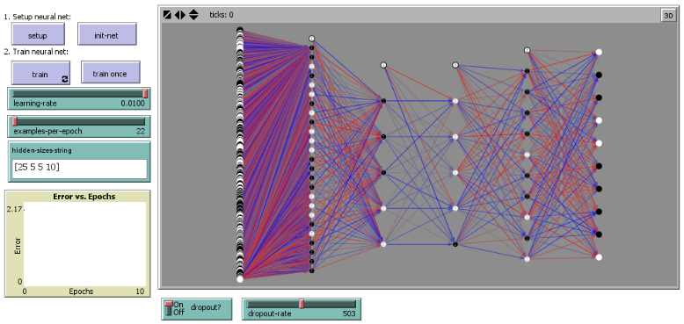
I attempted to maximize the generic-ness of my network model, while establishing enough robustness in normality, variance, and other measures to avoid convergence issues on an arbitrary network topology. In other words, I tried to avoid using non-standard optimizations and tricks to preserve fidelity to a generic network, while using enough standard manipulations to make sure that the network architecture will not (in general settings) interfere with the functionality of the network. I decided to use tanh as my activation function and the L2 norm for error calculation. I used standard practices to scale local learning rates and initialization values appropriately, and used explicit bias nodes to enhance visual comprehension of model training. The network is intended to simulate live training, with error measured per epoch used to compare the speed and accuracy of networks.
In terms of modeling decisions, I did not deviate far from the perceptron model I extended. Nodes represent neurons with input, output, bias, and hidden node breeds. Links are used to represent edges, and every node in some layer i is connected to every non-bias node in layer i + 1. Nodes still have an activation and error (for backpropagation) attribute, but I gave them estimated variance, local learning rate coefficient, and layer index attributes as well. Edges still have a weight attribute, and now have an attribute containing the layer index of their source node. I removed all of the globals (most of which referred to specific nodes) except for error-epoch, and added input size, output size, training data, testing data, and a hidden layer size array. After the data is loaded and the network is initialized, training executes as follows each tick:
Input Node: Set activation to my paired input value normalized between -1 and 1. Change color accordingly.
Hidden Node: With probability dropout-rate over 1000, set dropped? to true. Change color to gray and wait for the next round of calculation. At my layer’s step in propagation, set activation to tanh of the sum of the activations of my (not dropped out) anterior nodes, weighted by the weight of the link between that node and me. Change color accordingly. During backpropagation, set my error to the weighted sum of the error of my posterior nodes multiplied by the derivative of tanh at my activation value.
Output Node: At the last step in propagation, set activation to tanh of the sum of the activations of my (not dropped out) anterior nodes, weighted by the weight of the link between that node and me. Change color accordingly. During backpropagation, set my error to the difference of my activation and my paired classification value (1 if my index is the classification, -1 else). Add the L2 norm of my error to the epoch-error.
Links: If either of my linked nodes is dropped, set my color to gray and wait for next round of calculation. During backpropagation, change my weight by the product of the global learning rate, my posterior node’s learning coefficient and error, and my anterior node’s activation.
Repeat the above examples-per-epoch times, and graph the average error per epoch.
Because I designed this model as a visualization tool, I had hoped to find cases in which dropout learning performance far exceeded normal learning. From there, I intended to inspect the visualization of each of these trained networks, hopefully making some observation that would corroborate the common intuitions of why dropout learning is effective (breaking up over-utilized subnetworks and thus generalizing the hypothesis). To this end, I made a behavior space search varying learning-rate from .0025 to .01 by increments of .0025, dropout-rate from 0 to 750 by increments of 75, with dropout on and off, with 25 examples per epoch and 40 epochs per trial. Surprisingly, the data generated did not have dropout learning outperforming normal learning in general, and never by a particularly large amount. The maximal advantage in error was about 10% of the normal learning error, with the largest disadvantage slightly higher. On average, the difference between dropout and non-dropout learning error actually had normal learning performing slightly, and none of the examples observed had particularly enlightening visual differences. However, the lack of advantage from dropout was extremely suspicious, as dropout learning is a standard optimization technique for this kind of network. I tried running the behavior space search again with much, much lower dropout (between 0 and 10 varying by 2) in case I was removing nodes overzealously and only 20 epochs per trial in case I was measuring after the networks had stabilized. The results were almost identical, and again there were no visible distinctions between the networks in the cases with maximal dropout advantage.
While the results were inconclusive, I believe that the discrepancy between the typical advantages of dropout learning and what I observed is indicative of some bug or bad parameter choice preventing typical dropout learning. Given more time, I would investigate a much larger parameter space and thoroughly test that dropped nodes are neither contributing to activation scores nor learning while dropped. Additionally, I would turn dropped elements transparent rather than gray, in order to make other connections easier to view during dropout learning.
Despite the disappointing empirical results, I think this model could be extremely interesting to extend and test more thoroughly. One extremely easy to implement and useful feature (that occurred to me too late to implement) would be a “transparency threshold” where edges with weights under the threshold would turn transparent. If adjustable by a slider and implemented to update the view whenever changed, such a feature could make the desired visualization of strong connections and subtrees much more effective. Further potential changes would be the addition of the ability to test the output of individual values from the data set, the addition of more common optimization techniques (such as ensemble learning, convolution, etc) with the hope of finding more visual intuitions about the way such techniques effect learning. More importantly, the optimization of the implementation itself and the ability to prevent data from being loaded each trail during the behavior space search would make the model a much more useful research tool, as even the small behavior space tests above took hours to execute.
I will be extremely glad to have this visualization tool for future projects, through I’m concerned by the problems with dropout learning and the implications for the model’s reliability. After resolving the issues with dropout and implementing some of the improvements above, I think that this model could be used to make conceptualizing “network structure space” much easier, and would certainly be an easy way to generate arbitrary networks to work with and visualize. While the model does not produce any particularly unusual outputs or new emergent properties in and of itself, I believe that it could help capture the qualitative side of many concepts and research questions in machine learning.

