SIMULATING NATURAL SELECTION: A NetLogo Model

Based on the board game by
Robert P. Gendron Indiana University of Pennsylvania

We know from the fossil record that species change (evolve) over time. Darwin argued, and this has subsequently been confirmed, that the primary mechanism of evolutionary change is the process of natural selection. Given that evolutionary theory is the most important unifying principle in biology, the importance of understanding natural selection is obvious. The problem is that under most conditions this process is relatively slow, occurring over many generations. Fortunately, with the help of a simulation we can study how natural selection works in a relatively short time.

For many years biologists have used simulations as a tool for understanding ecological and evolutionary processes. These simulations can be extremely complex and require the use of a computer, or they may take the form of relatively simple "games." In this lab you will play a game that simulates the interaction between a population of predators and its prey over several generations. By the end of the exercise you should have a better understanding of how natural selection changes the genetic make-up of a population.

You will recall that several conditions are necessary for natural selection to occur:

1. VARIABILITY. Individuals within a population must be different from each other. These differences may involve characteristics such as resistance to cold, susceptibility to disease, photosynthetic efficiency or the ability to attract a mate, to name just a few.

2. HERITABILITY. Some of the variability between individuals must have a genetic basis. Thus offspring will tend to resemble their parents and have the same traits.

3. DIFFERENTIAL REPRODUCTION. Individuals with some traits will leave more descendants than others. This could be either because they survive longer (e.g. faster animals are better at escaping from predators) or because they have a higher reproductive rate (e.g. a bird with more colorful plumage may attract more mates.)

It should be obvious that, given these conditions, the traits of successful individuals will gradually become more common in the population. In effect, the environment "selects" some traits over others.

In this simulation you will look at the evolution of two traits, camouflage in a prey population and visual acuity in predators. Each individual within a population has a number that indicates the effectiveness of its camouflage (if it is a prey) or vision (if it is a predator). During the simulation surviving individuals will periodically reproduce. As in nature, offspring are similar, but not identical, to their parents. In this simulation selection results from differential mortality; prey with poor camouflage are more likely to be killed by predators and predators with low visual acuity are more likely to die of starvation.
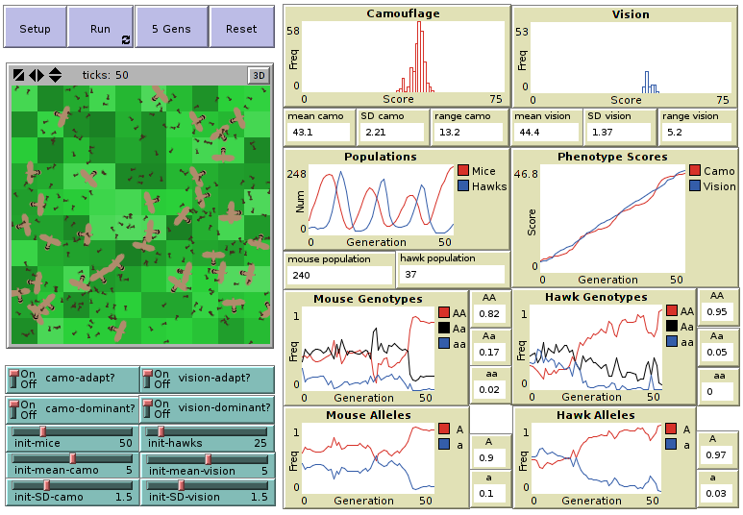

Directions:
Read the Info tab for the model to familiarize yourself with how the model works. Look up any terms with which you are unfamiliar. You will be running the model numerous times as you explore factors affecting natural selection. You should fill in one data sheet and take 3 screenshots for the default settings and for EACH experiment you perform.

Start by pressing the Reset button to run the model using the default settings:
- Run the model as follows:
  - Press the Setup button.
  - Record the settings for each switch and slider in Table 1 of the data sheet.
  - Record the initial values for each output variable in Table 2 of the data sheet in the column labeled “1”
  - Press the 5 Gens button to run the model for 5 generations.
  - Make predictions about what you think might happen in the next 5 generations. Be sure to explain WHY you think so.
  - Repeat steps (d) – (e) until you have run the model for 50 generations.
  - Take a screenshot of the final model output and paste it into a Word document
- Run the model two more times with the same settings as follows:
  - Press the Setup button
  - Record the initial values for each output variable in Table 2 of the data sheet in the columns labeled “2” (Run 2) or “3” (Run 3)
  - Press the Run button to run the simulation for 50 generations.
  - Take a screenshot of the final model output and paste it into a Word document

Experiment with the model:
Use the THNGS TO TRY and THINGS TO NOTICE from the Info tab for ideas. Change only one or two settings at a time. Run each experiment using the sequence of steps listed above (DO NOT Press the Reset button. That will erase your experimental settings!) . That is run the first trial of your experiment 5 generations at a time making and explaining predictions between each 5 generation run. Repeat the experiment 2 more times for each experiment using the Setup and Run buttons to run the second and third trials over 50 generations. Fill out a data sheet and take screenshots for all three trials. Be prepared to present your experimental findings in a whiteboard meeting.
Analysis Questions (Write your answers on a separate sheet in complete sentences)

- Did the average camouflage and visual acuity scores increase or decrease? By how much?
- What mode of selection is demonstrated by your results. Explain the selective forces at work that result in this outcome.
- Define coevolution and explain how this simulation is an example of coevolution.
- Compare the initial and final frequency distributions. Did the variability of the two populations change? By how much? (Hint: an approximate measures of variability are the standard deviation and range of scores for each population.)
- Explain why genetic variation allows a population to survive during environmental changes.
- You probably noticed that there is an element of chance in this simulation that can cause the average scores to fluctuate erratically. Explain. Give two examples of chance events that might affect the course of evolution in nature.
- If the initial size of each population was much larger (e.g. 1000 instead of 16) would the effect of chance events on evolution be more or less important? Explain.
- Sometimes in these simulations a population will go extinct. Is extinction more likely for a small or large population? Why? (Hint: consider both mating probability, genetic diversity and natural selection)?
- Did the size of the prey and predator populations change during the simulation? How and why?
- Draw a causal (feedback) loop diagram to explain your observed predator prey interaction.

Natural Selection Game Data Sheet Name __________________________

Experiment description and rationale:

Table 1: Model settings
Mice |  | Hawks
Setting | Value | Setting | Value
camo-adapt? |  | vision-adapt?
camo-dominant? |  | vision -dominant?
init-mice |  | init-hawks
init-mean-camo |  | init-mean- vision
init-SD-camo |  | init-SD- vision

Table 2: Initial output variable values
Mice |  |  |  | Hawks
Output Variable | Initial Value |  |  | Output Variable | Initial Value
Output Variable | 1 | 2 | 3 | Output Variable | 1 | 2 | 3
Population |  |  |  | Population
Mean camo |  |  |  | Mean vision
SD camo |  |  |  | SD vision
Range camo |  |  |  | Range vision
AA |  |  |  | AA
Aa |  |  |  | Aa
aa |  |  |  | aa
A |  |  |  | A
a |  |  |  | a
Predictions:

