Ross Busch
Professor Cickovski
Revised ODD
Question: | How much will an action movie, or a rom-com movie, gross in sales? Which will perform better?
Entities: | Observer, Movie Goer, the kind of movie
Static Variables: | Gender, age, social-network, distance, ticket price, theater?, female-friends, male-friends, possible-female-friends, possible-male-friends
Dynamic Variables: | Distance, bought-ticket?, rom-com
Global Variables: | Max-female-friends, max-male-friends, rom-com-revenue, action-movie-revenue, social-network, switching-chance, num-theaters, max-social-network-size, female-population-percentage, age1%15-30, age2%31-45, age3%46-60, age4%61-75, other%
Scales: | 1 tick is equal to one day, stop ticks after 60 days
Process, overview and scheduling: | Create turtles based on city demographics and population which the user decides. Create a number of movie theaters based on the user’s input.
Basic Principles: | The design goal is to create a model where the impacts of age, gender, and social network, can be identified on movie choice. Age ranges will be established by given demographic ranges in selected city, gender will be represented by either female or male and given separate colors to identify gender, and social network will be defined by the age of the turtle in the NetLogo world and its gender. To effectively control for an accurate ratio of male : female friends in friend group, our model suggests using a facebook app or a student survery to analyze how many male and female friends a user has. Gender composition of the model will be controlled by a slider, female-population-percentage. Whereas male population percentage will be defined by 100 – female-population-percentage. Regarding age, we will allow the user to input their age breakdown via sliders 15-30, 31-45, 46-60, 61-75, and an “other” slider. The “other” slider will ensure that the previous breakdowns all add up to equal 100.
Emergence: | The primary output of the model would be revenue based on movie choice. This distribution would emerge after age, gender, and social network, impact the decision making process of the turtle.
Adaptation: | Turtles will adapt to the behavior of their social network, and will react to the popularity of a movie at a given theater. However, turtles will not be able to change their social network, their age, or gender.
Objectives: | The objective of this model is to determine which movie will gross more sales.
Learning/Prediction: | Not in the current model.
Sensing: | Sense their social network and their network’s movie choices, distance from theater, and what movie other turtles are going to see.
Interaction: | Turtles will interact with their social group.
Stochasticity: | Weather.
Collectives: | Collectives include male and female choices, and age ranges.
Observation: | Gross sales bar graph.
Initialization: | The model is initialized with turtles being created to reflect the demographics of the city selected by the user. Therefore, age, and gender are placed in the model based on the observer’s census data. Social network is defined by a turtle’s gender, age, and a maximum social network size of 10.

See Screenshots Below!

Figure 1
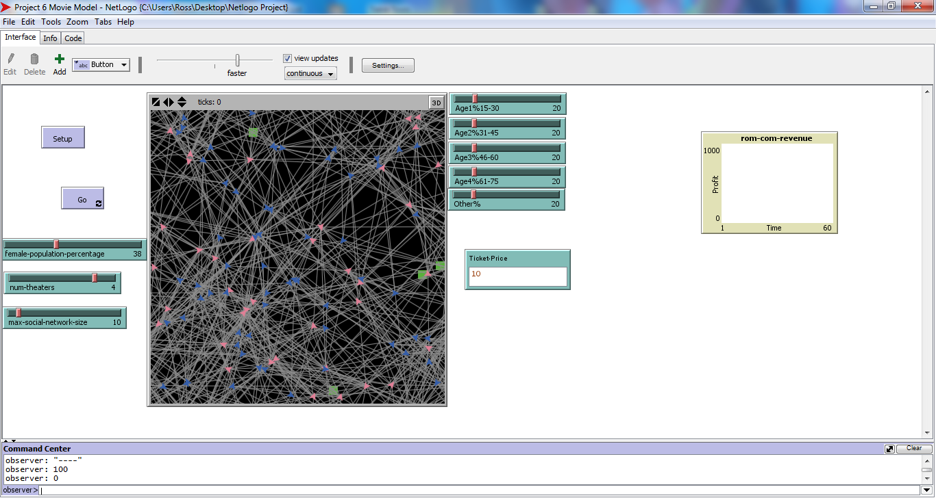
- After clicking “setup” the model should appear as it does in Figure 1. Notice how the theaters are represented by green patches, and the turtles are divided by colors. Male turtles are blue, and female turtles are pink. The gray lines represent the linkages within the turtle’s social network. At this point in time, the turtles have not bought their tickets yet and are waiting for the user to select “go.” The user can select the number of theaters by altering num-theaters on the slider. Female population percentage, and subsequently, male-population-percentage can be set by the other slider. The group of sliders on the right is adjustable age range by percentage. The age range is one variable that affects the social network. Another global variable that would affect social network is the max social network size. The social network affects movie choice and therefore the revenue that a movie makes.

Figure 2
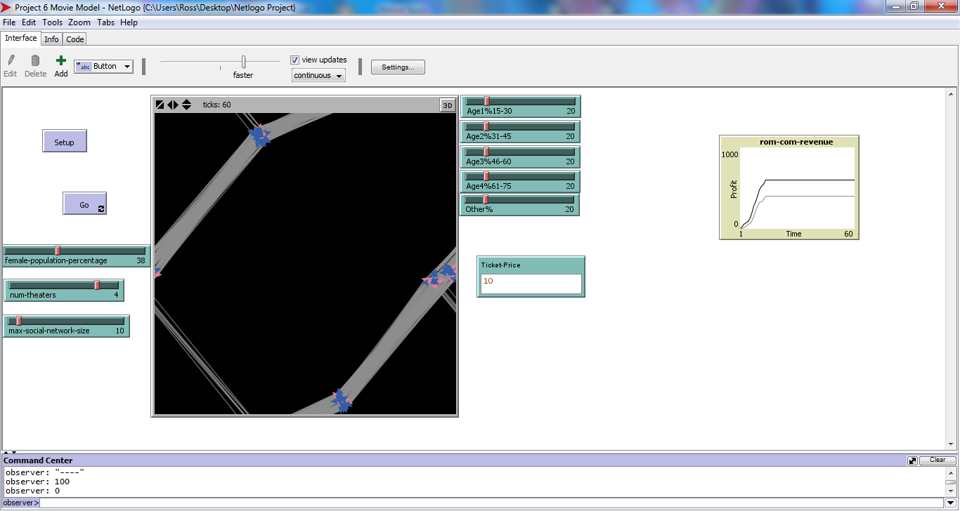

Once the model has run, revenue for both movies will be recorded on the plot. The black line on the plot is rom-com-revenue and the gray line is action-movie-revenue. Turtles have all gone to a theatre and the social network lines should connect theatre to theatre. The model should look something like Figure 2.
Bibliography:
Fischoff, S., Antonion, J., & Lewis, D. (1998). Favorite Films and Film Genres As A Function of Race, Age, and Gender. Journal of Media Psychology, 3(1). Retrieved April 1, 2015, from http:://web.castatela.edu/faculty/sfischo/media3.html.

