EECS 372
6/8/2015
SangHee Kim
Professor Wilensky
Analysis of Planned Economy
Introduction
Earlier into the model, my plan encapsulated a much broader subject; it was to be a comparative model of two rising civilizations that would interact with each other by means of trade and warfare, all the while managing its own internal economy. This would have been a step towards answering the question: “Is it possible to create a perfect nation through planned economy in a competitive situation?” By allowing the users to change the amount of workers, tradesmen, consumers, and soldiers with limited, predetermined resources, the model would allow the users to see what combination will allow for the ultimate victory between the two civilizations. However, I found that this would not be a sustainable model to code in such a short amount of time, and thus began scraping away the codes. Narrowing the scope down, I have settled down to focus solely on the planned domestic economy, wherein the users will be able to set up a city with predetermined parameters. The question that now drives this revision is “How should government manage the ratio of businesses to manufacturers in order to provide maximum domestic income, i.e. maximize prosperity?”
Agents and their behaviors
The new iteration puts heavier emphasis in the flow of money between the two agentsets: businessmen and workers. The businessman turtles will travel between their homes and their workplaces (retailers), and worker turtles will similarly travel between their homes and factories. These actions are the turtles’ method of directly earning money, which is calculated as 1% of the workplaces’ revenue. Going beyond these basic patterns, the workers may also go shopping by choosing a retail store that is nearest to its house as the favorite one, spending money that goes towards increasing the business’s revenue. Therefore, in theory, businesses that are located nearest to the clusters of workers’ houses will earn greater revenue. The businessmen, too, will also conduct business with a factory that is chosen randomly as a business partner at the initial setup, acting as the middleman agents that will transfer money between factories and businesses. These behaviors, of course, will often favor one workplace over another depending on the randomly selected locations; sometimes, the workplaces may go bankrupt due to lack of revenue due to lack of customers or business partners. These places are reflected in-model with black squares, and if this were to happen, the turtles would relocate to another workplace and start working there. These behavior patterns are set to simulate the most basic interactions within a market economy.
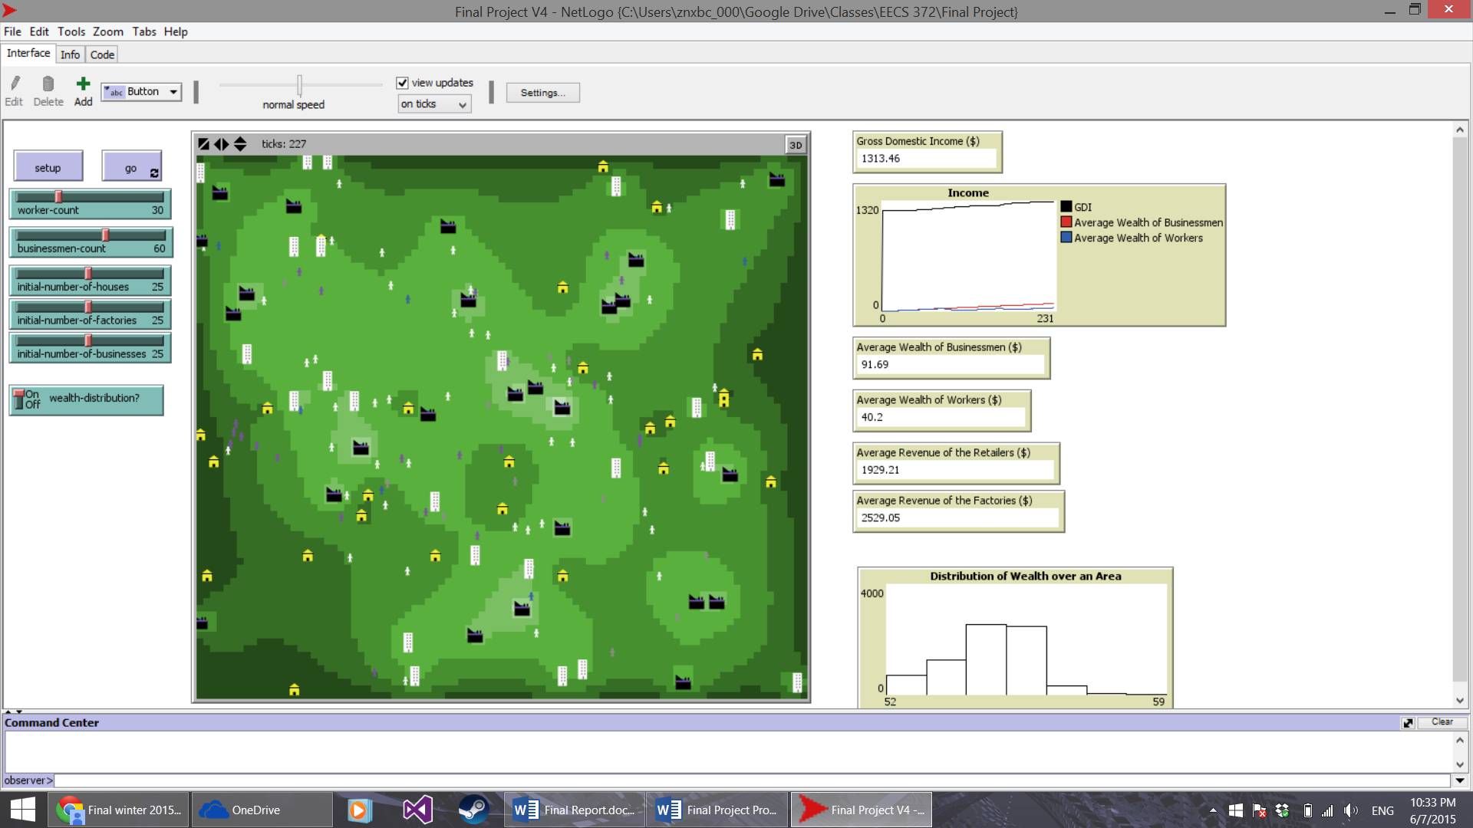
The patches themselves possess numerous variables. The factory and business patches that are randomly chosen in the initial setup will have values that contain those patches’ revenues and incomes (the amount of money that the turtles will receive upon completing the routine actions). Other patches also contain information such as the wealth of the area, which is calculated by taking the surrounding patches’ income and dividing by 8, the number of neighbors.
Each of the different shades of green represents different levels of wealth. Lighter shade means that the area is wealthier. Factories are represented by the turtle that is highlighted with blue circle, while retailers are represented by the one with the red circle.
Because of the coding structure that involves interaction between many individual agents with their own goals, it would be most suitable as an agent-based model; it allows for users to easily see how the simple actions of each agents culminate into much a larger result. For instance, if this was a single-variable simulation focusing only on one agent’s actions throughout the day, it would be impossible to see the overall result of the economy because of the limited perspective that the model would provide, however detailed the agent’s codes are.
The parameters are set so that they are reliant on the initial setup, and the users cannot interact with the models afterwards. The parameters control the number of each types of agents to be generated, as well as the different types of the buildings. If the users choose to do so, they could have the model run with only one factory and 50 retailers. Setting the model with different parameters have resulted in interestingly varying results, as will be explained later.
Time steps
The model, once initialized with the given parameters, will usually follow similar steps until differences begin to emerge. At first, the model will take a few seconds to fully update the green patches with correct wealth of the area. The turtles will begin following their respective set of actions, such as going to workplace and going to shopping. After a moment, the initial wide spread of lighter-colored wealthy area will shrink. With most parameters, it seems that the wealthy agents will likely remain wealthy whereas the poor will stay poor. This was the case with large majority of the cases that have been tried thus far, which led me to think that, in a planned economy, the class division cannot be avoided.
Worker-count sets the initial number of workers.
Businessmen-count similarly sets the initial number of businessmen, and so on with the rest of the parameters.
Limitation of the model
However, it should be noted that this model contains several limitations that prevent it from being a complete simulation of an economy. For instance, the model does not take into consideration the other expenditures that people might have in real life, such as house payments. There is also no outside factors such as international conflicts or trade agreements, which makes this model a particularly isolated example, although this may be preferred depending on what policies the nation is following at the time. Also, other than the initial setup, there is absolutely no government involvement as well, so both the businesses and factories can operate without having to worry about taxes, which is an unnatural degree of freedom, given how the government with planned economy would have more heavy-handed approach.
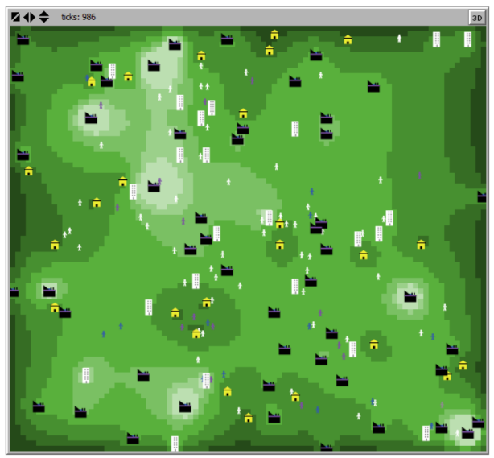
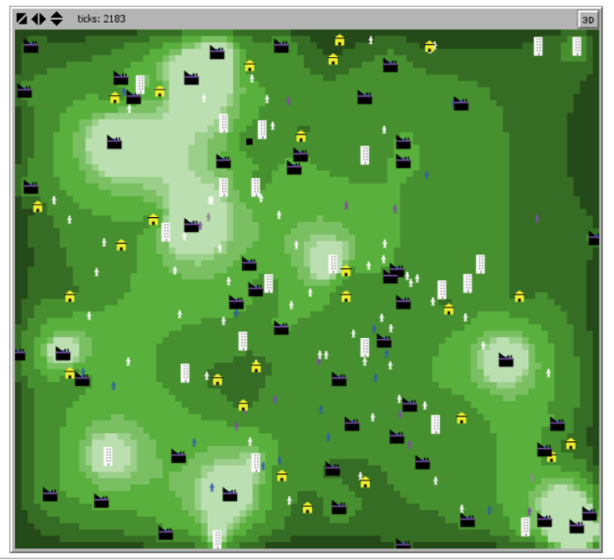

This figure showcases the extent to which the wealthy becomes wealthier and the poor becomes poorer. Notice the arrows and how much the patches with lighter shades of green has shrunk, and how the centralized wealthy areas became wealthier.

Analyzing the Result and Conclusion
However, despite these limitations, there were some interesting results from the model that may be worth mentioning. When the number of businessmen and workers were kept constant, the model created a huge, centralized wealthy area that dissolved soon after. However, while it lasted, the wealth discrepancies were such that there were only thin layers of intermediate shades of green between the wealthy and the poor. The model yielded similar results when there were twice as many businessmen as there were workers, although with smaller centralized wealth distribution, as well as the lowest GDI compared to other configurations. However, when there were twice as many workers as there were businessmen, the wealth distribution became more decentralized, although the class difference between the rich and the poor still existed. It also yielded the highest GDI and average revenue across all sectors (the GDI was $305,841.23 compared to $117,262.95 when it was 1:2 workers-to-businessmen, almost three times higher). This was true across several runs, leading me to believe that, at this stage, keeping a consistent 2:1 workers-to-businessmen ratio might yield the best result.
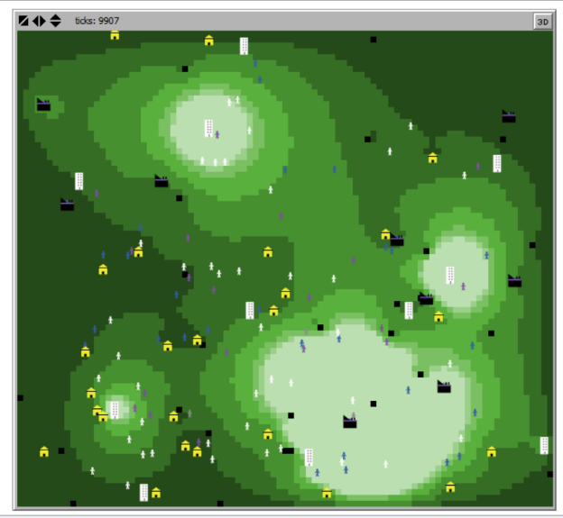
This may make sense taking into consideration what situation drives the society to adopt planned economy, mainly due to government influence. For instance, South Korea, rebuilding itself decades after the Korean War, exponentially increased its Gross Domestic Product by becoming a manufacturing powerhouse that gave way to more powerful businesses under the rule of the Korean dictator Park Chung-hee. Therefore, under the circumstances presented by this model – isolated city, lack of resources, totalitarian government – it might make sense that a startup nation will be better off focusing on manufacturing.
Notice the considerable discrepancy illustrated by the circle; the class division between the wealthy and the poor is fairly dramatic, as illustrated here.

