Progress Report – May 16th

Magdalena Olewinska EECS 372

SUMMARY OF CHANGES
Reconstructed the model: Removed employee turtles and thus all decision and line links. Moved all the employee turtle responsibilities to the checkout station patches and now implement queueing spatially. Customers now select checkout station based on shortest line created at the moment instead of waiting for a checkout station to be not busy and then selecting it. Customers keep track of their wait-time and check-out stations keep track of customers helped and items scanned. Monitor average wait time for customers in line and monitor cost of stations opened.
Decided to model the queuing mechanism by experimenting the effects of different strategies and check-out layouts implemented by the store. This leads to more emphasis on dynamic layout changes and cost analysis from the store perspective. Wait time for customers will still need to be measured to note tradeoffs for stores when comparing to cost of the given layout; therefore, a basic heuristic for selecting a line can be applied since will just be used as a benchmark.

KEY FOR PROGRESS
GREEN WORDS = NEW BLUE WORDS = CHANGED RED WORDS = REMOVED

Agent behavior: How do the agents behave/work?
There are 2 types of patches at the moment: general check-out (blue) and X items or fewer check-out (green). There is one type of customer arrival schedules that reflect the density of incoming customers: uniform. The two breeds of turtles. There are employees who match the color of their checkout station and who start the head of a line for a checkout station. There are customers with a randomly assigned item count assigned from 1 to 100. There are two types of links: undirected decision links that connects a customer with the employee at the station selected and directed line links that creates the line/order of customers to be serviced by the head of the line, the employee. Customers choose the shortest line available upon their arrival that they are eligible for and move to the end of the line. Max capacity of the store is set to be 150 customers at any given time.

System behavior: How does the overall system behave/work?
Comparing the average wait time with the same parameters for multiple runs is not similar as I expected. Below is a screenshot from tick: 7816. This is not a realistic scenario as there are customers waiting in long lines while there are shorter lines available than their current line. The basic heuristic for choosing a checkout station either will need to be modified or switching checkout stations will have to be implemented for the customers.

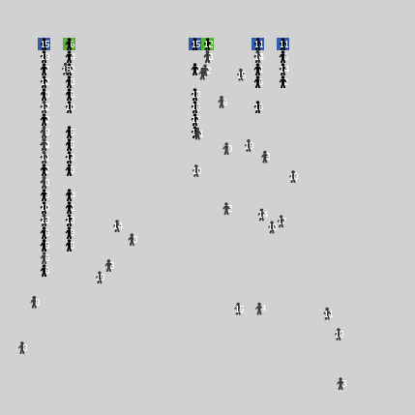
At the moment customers wait without being in line to choose a checkout station to decide on and then link with the associated employee operating that station. Many customers are linked to an employee and everyone gets serviced once they arrive at the station. This is not realistic as only one customer can be serviced at a time so Line Links as described above will have to be implemented.

Rationale for agent rules: Why did you give the agents these rules?
Customers enter line at station that has the fewest amount of people that have already arrived at the checkout station. If a customer qualifies for the X items or fewer line, will consider these checkout stations as additional options and weigh them equally. This is a basic heuristic for selecting a line. In the future will consider changing it to weigh perhaps distance from station and approximately how many items per customer in line to the selection heuristic.
Checkout Patches: If customer standing on it, decrease the amount of groceries by the scan rate per tick. They have max-items they can handle that correspond to the station type. They track customers helped and items scanned.
Employees: Employees stand behind corresponding checkout patch. They have max-items they can handle that correspond to the station type. They track customers helped by the employee. They are busy when they a customer has arrived and are servicing them.
Customers: Customers have between 1-100 groceries and start off with “no-line” and as a dark grey color. They select a station to go to if the checkout station is not busy (not servicing anyone at the moment) and is that is capable of handling that many items and has the fewest customers already “in-line”. At that point, they mark themselves as having “found-line”. Customers head toward the checkout patch and when they arrive mark themselves as “in-line”, turn black, and receive a wait-number indicating their place in line. They keep moving down the line until find an empty patch. On each tick, if patch in front of it is empty, move up and decrease wait-number. They increase their “wait-time” at every tick they remain “in-line”.
Decision Links: Upon selecting which station to go to, the customer creates an undirected link to the employee of the station which will be deleted upon arrival and a corresponding directed line link to the tail of the queue with the employee as head.
Line Links: To be implemented to make checkout process realistic.
These rules were given to set up and test the flow of the model. More decisions based on user input or probability will be implemented to reflect realistic scenarios.

Model output: Have you developed new measures for the output? Do you think your model currently provides a good description of the system’s behavior? Why or why not?
Currently the model outputs how many customers are at the store at a given time. The model tracks average wait time of customers in line over the duration of the model. It also tracks the cost of operation based on the number and types of checkout stations open (currently this is stable as the store layout is static). Eventually these measures will allow analysis of tradeoffs between customer wait time and cost of operation per layouts chosen.
Do not have measures to highlight any of the patterns I am looking to analyze in terms of what is the most efficient layout from the store and the customer perspective.

Questions: What questions do you have about your model?
How to implement dynamic opening and closing of checkout stations in a realistic manner; do specific throughput details about existing checkout stations need to be monitored?
How to verify model? How to validate model?
What kind of variables will be accessible to the user? What kind of measurements will be the most interesting to see and how to output them so easy to understand?

Next steps: Briefly list your next steps for improving the model.
- Add switch to allow dynamic opening and closing of checkout stations.
- Add store layouts of one line that leads to multiple stations.
- Add store layouts of self-checkout stations.
- Add another two customer arrival schedules that follows a bell curve and a sine curve.

Model Analysis: What conclusions can you draw from the model’s output?
No conclusions can be drawn yet as the model is incomplete in functionality.

